

**DEDAN KIMATHI UNIVERSITY OF TECHNOLOGY**

**PRIVATE BAG - 10143, DEDAN KIMATHI, NYERI, KENYA**

**SCHOOL OF ENGINEERING**

**DEPARTMENT OF CIVIL ENGINEERING**

**BACHELOR OF EDUCATION TECHNOLOGY (CIVIL ENGINEERING)**

**TITLE: ENHANCING CONCRETE STRUCTURAL DESIGN: PREDICTIVE MODELING FOR TENSILE STRENGTH EVALUATION**

|  |  |  |
| --- | --- | --- |
| **Registration No.** | **Name** | **Signature** |
| E033-01-2336/2020 | NELLY NKIROTE |  |
| E033-01-1386/2020 | JOSEPH GATHITHI WATHOME |  |

**SUPERVISOR: Dr. ERASTUS KAROKI**

*Final Project Submitted to Dedan Kimathi University of Technology in Partial Fulfillment of the Requirements for the Award of the Degree of Bachelor of Technology in Civil Engineering.*

**2024**

# **DECLARATION**

We affirm that this project is entirely our own work, with due acknowledgment provided in the text where appropriate. To the best of our knowledge, it has not been previously submitted for the purpose of obtaining a degree or diploma at Dedan Kimathi University of Technology or any other educational institution.

Signature: __________________ Date: ___________

Nelly Nkirote

**E033-01-2336/2020**

Signature: ___________________ Date: ____________

Joseph Gathithi Wathome

**E033-01-1386/2020**

This project has been submitted with our approval as the university supervisors.

Signature: Date:

**Dr. ERASTUS KAROKI**

**DeKUT, Kenya.**

# **ACKNOWLEDGEMENT**

We express our profound gratitude to the Almighty for His abundant blessings, unwavering protection, invaluable guidance, and the wisdom that has led us to this juncture, enabling us to present this project proposal.

We extend our heartfelt appreciation to the Department of Civil Engineering for their steadfast support throughout this journey, as well as for providing the essential resources that have propelled our efforts.

Special recognition is reserved for our families and fellow classmates, whose unwavering moral support and contributions, whether direct or indirect, have been instrumental in our achievements. Without them, this endeavor would have been a far more challenging undertaking. May the blessings of the Almighty be upon each and every one of you.

`

**TABLE OF CONTENTS**

**DECLARATION** 2

**ACKNOWLEDGEMENT** 3

**LIST OF FIGURES** 6

**LIST OF TABLES** 7

**ABBRIVIATIONS** 8

**ABSTRACT** 9

**1.0** **INTRODUCTION** 10

**1.1** **BACKGROUND OF THE STUDY** 10

**HISTORY OF TENSILE STRENGTH OF CONCRETE** 10

**1.2** **STATEMENT OF THE PROBLEM** 11

**1.3** **OBJECTIVES** 12

**1.3.1** **General Objectives** 12

**1.3.2** **Specific Objectives** 12

**1.4** **SCOPE AND LIMITATION OF STUDY** 12

**1.4.1** **Scope of Study** 12

**1.4.2** **Limitations of the Study** 13

**1.5** **SIGNIFICANCE AND JUSTIFICATION OF THE STUDY** 13

**1.5.1** **Significance of the Study** 13

**1.5.2** **Justification of the study** 13

**2.0** **LITERATURE REVIEW** 15

**2.1** **INTRODUCTION** 15

**2.2** **TENSILE STRENGTH OF CONCRETE Vs COMPRESSIVE STRENGTH OF CONCRETE** 15

**2.3** **TENSILE STRENGTH OF CONCRETE** 16

**2.4** **MATERIAL SELECTION** 18

**Cement Types** 18

**Admixtures** 19

**Aggregates** 21

**Aggregate/Cement ratio** 22

**2.5** **CONCRETE CURING** 22

**2.6** **NEURAL NETWORKS** 23

**2.7** **CASE STUDY** 24

**2.8** **LITRATURE REVIEW SUMMARY AND RESEARCH** 25

**2.8.1** **Summary** 25

**2.8.2** **Research Gap** 25

**2.9** **CONCEPTUAL FRAMEWORK** 26

**CHAPTER THREE** 27

**3.0** **METHODOLOGY** 27

**3.1** **GENERAL.** 27

**3.2** **RESEARCH DESIGN.** 27

**3.3** **MATERIAL SOURCING AND PREPARATION.** 27

**3.2.1** **Material Sourcing** 27

**3.2.2** **Aggregate Sourcing** 28

**3.2.3** **Water** 28

**3.2.4** **Admixture Sourcing** 28

**3.3** **CONCRETE MIX DESIGN AND PROPORTIONS.** 29

**3.4** **Data Collection** 30

**3.4.1** **Sample Preparation** 30

**3.4.2** **Sample Curing** 32

**3.4.3** **Tensile Strength Testing** 32

**3.5** **DATA PREPROCESSING.** 34

**3.5.1** **Data Augmentation.** 34

**3.5.2** **Tensile Strength Calculation** 35

**3.6** **DATA ENGINEERING.** 36

**3.7** **FEATURE SELECTION.** 37

**3.8** **ENCODING.** 38

**3.9** **SPLITING AND NORMALIZING** 39

**3.10** **MODEL DEVELOPMENT** 40

**3.11** **LOSS FUNCTION AND OPTIMIZATION** 42

**3.12** **TRAINING** 44

**3.13** **EVALUATION** 45

**3.14** **MODEL SAVING.** 47

**3.15** **MODEL PREDICTION.** 48

**3.15.1** **Data Collection** 48

**3.15.2** **Predictions** 49

**3.15.3** **Making Predictions** 50

**CHAPTER FOUR** 52

**4.0** **RESULTS, ANALYSIS AND DISCUSSION** 52

**4.1** **INTRODUCTION.** 52

**4.2** **DATA COLLECTION.** 52

**4.2** **DATA PROCESSING.** 52

**4.3** **EFFECT ON TENSILE STRENGTH.** 53

**4.4** **THE MODEL.** 54

**4.4.1** **Model Development** 54

**4.4.2** **Model Training.** 55

**4.5** **EVALUATION** 57

**4.6** **TESTING** 59

**CHAPTER FIVE** 60

**5.0** **CONCLUSION AND RECOMENDATION** 60

**5.1** **DATA COLLECTION PROCESS** 60

**5.2** **MODEL PREDICTION ON NEW DATA** 60

**5.3** **RECOMMENDATION** 61

**REFFERENCE** 62

**APPENDICES** 64

**APPENDIX I WORK PLAN** 64

**APPENDIX II BUDGET** 65

**APPENDIX III EXPERIMENTAL DATA** 65

**APPENDIX A - Data collected.** 65

**APPENDIX IV LAB SAMPLE PREDICTION** 66

**APPENDIX A – THE TABLE** 66

**APPENDIX B – Sample A prediction** 67

**APPENDIX C – Sample B prediction** 68

**APPENDIX D – Sample C prediction** 69

**APPENDIX V MODEL IN USE VIDEO LINK** 69

**APPENDIX VI SOURCE CODE FOR THE MODEL** 69

**APPENDIX VII PICTURES** 70

# **LIST OF FIGURES**

Figure 3. 1 Data Augmentation 35

Figure 3. 2 Tensile strength calculation 36

Figure 3. 3 Converting null values of Admixtures 37

Figure 3. 4 Null values 37

Figure 3. 5 Feature selection 38

Figure 3. 6 Encoding 38

Figure 3. 7 Spliting and Normalization 40

Figure 3. 8 Model 40

Figure 3. 9 Loss and Optimization 42

Figure 3. 10 Loss function Curve 42

Figure 3. 11 Optimization presentation 43

Figure 3. 12 Training 44

Figure 3. 13 Evaluation with R-squared, Mean absolute error and Mean squared error 46

Figure 3. 14 Model Saving 47

Figure 3. 15 Code for asking the user for data so as to use the data in in prediction 48

Figure 3. 16 Prediction 49

Figure 3. 17 prediction by using code to initialize the saved model 50

Figure 4. 1 Tensile Strength of Diffrent Types of Cement 53

Figure 4. 2 Model Architecture 54

Figure 4. 3 Model initialization 55

Figure 4. 4 Learning Curve Losses against Epoch on training vs Validation 56

Figure 4. 5 Evaluation 57

Figure 4. 6 Actual vs Predicted values 58

Appendix 1 Sample A Prediction 67

Appendix 2 Sample B Prediction 68

Appendix 3 Sample C Prediction 69

Appendix 4 Example of Cement used the White Portland Cement 70

Appendix 5 Us preparing and casting the samples 71

Appendix 6 Removing the samples from cast so as to Cure the samples 72

Appendix 7 Examples of samples from the Curing Drum 73

Appendix 8 Sample on the Machine before testing 74

Appendix 9 Performing Test on Sample 75

Appendix 10 Samples before testing is done after they have dried up 76

Appendix 11 Preparing the machine for testing 77

Appendix 12 Scale Before testing Begins 78

Appendix 13 Before Test Begins 79

Appendix 14 After Test is completed 80

Appendix 15 The sample After testing Tensile strength 81

# **LIST OF TABLES**

Table 3. 1 Mix design and proportions 29

Table 3. 2 Datasheet format 34

Table 4. 1 Three Lab Sample testing results 59

Appendices Table 1 Work Plan 64

Appendices Table 2 Budget 65

Appendices Table 3 Experimental data Sample of data collected 65

Appendices Table 4 The 3 data samples for prediction 66

# **ABBRIVIATIONS**

OPC - Ordinary Portland Cement.

PPO - Portland Pozzolana Cement.

NNM - Neural Network Model.

# **ABSTRACT**

This research project precisely focuses on enhancing the structural design of concrete by developing a predictive model for its tensile strength. Key parameters such as the type and quantity of cement, water content, curing duration, aggregate size, and type of admixtures were carefully selected as inputs for our model.

The primary objective of the study was to create a neural network model using Python and PyTorch that can accurately predict the tensile strength of concrete. To achieve this, the type of cement, admixtures, and aggregate size were meticulously selected and measured to cast cylindrical molds of 200 by 100 mm dimensions. A total of 27 molds were cast and cured for a duration of 7 days.

Tensile strength tests were conducted on each sample and the data was recorded. This collected data was then preprocessed and portioned for use in the neural network model. The model, consisting of 4 layers including 2 hidden layers, was trained with 80% of the data. The performance of the model was assessed using R-squared Mean Squared Error and Mean Absolute error, and iterative improvements were made to enhance accuracy.

The remaining 20% of the data was used to test and refine the model’s accuracy by adjusting nodes, layer weights, and biases. For further validation, the model was tested using three additional datasets from the lab and we found it has a an average of 78% accuracy.

The findings suggest that the developed model could significantly impact civil engineering practices, including risk mitigation, crack prevention, and reinforcement design. The study challenges the widespread belief of a deterministic relationship between the compressive and tensile strengths of concrete, highlighting the need for independent evaluation.

By using the neural network model, the study not only addresses the issue of tensile strength but also provides a practical approach to producing durable structures. In summary, this research offers a significant contribution to the field of civil engineering by providing a robust predictive model for concrete tensile strength.

# **INTRODUCTION**

The tensile strength of concrete is a critical property in civil engineering, influencing the durability and structural integrity of constructed elements. Despite its importance, accurately predicting tensile strength remains a complex task. This project proposes the development of a Python-based neural network model with PyTorch to predict concrete tensile strength with high precision.

## **1.1 BACKGROUND OF THE STUDY**

The tensile strength of concrete is a critical property that directly affects the structural integrity and durability of buildings. However, accurately predicting this property has been a challenge in the field of civil engineering. According to a study by Bagher Shemirani and Lawaf (2023), machine learning methods have shown promise in predicting the tensile strength of concrete, indicating the potential of computational models in this area.

The American Society for Testing and Materials (ASTM) provides standard test methods for determining the tensile strength of concrete. The ASTM C496-11 outlines the standard test method for split tensile strength of cylindrical concrete samples. This standard provides a reliable method for testing the tensile strength of concrete, which will be crucial in the development and validation of the proposed model.

Furthermore, the ASTM C150-07 provides the standard specification for Portland cement, a key component in concrete. Understanding the properties of the cement used in concrete is essential as it significantly influences the tensile strength of the final product.

In his book “Understanding the Tensile Properties of Concrete,” Jaap Weerheijm (2013) discusses the importance of tensile properties in concrete and how they influence the overall performance of concrete structures. This work provides valuable insights into the factors affecting the tensile strength of concrete and will serve as a key reference in the proposed project.

This project aims to build upon these foundational works and develop a model that can accurately predict the tensile strength of concrete, thereby contributing to the field of civil engineering. The proposed model will consider key features such as the type and amount of cement, curing duration, aggregate size, and admixtures. The performance of the model will be evaluated using metrics like Mean Squared Error and R-squared, and iterative refinements will be made for enhanced accuracy.

### **HISTORY OF TENSILE STRENGTH OF CONCRETE**

The history of the tensile strength of concrete is intertwined with the history of concrete itself and the evolution of construction materials and techniques. Here’s a detailed look at this history:

**Ancient Times**

The use of concrete dates back to ancient times, with the Egyptians using early forms of concrete over 5000 years ago to build pyramids. They mixed mud and straw to form bricks and used gypsum and lime to make mortars.

**Roman Era**

The ancient Romans used a material remarkably close to modern cement to build many of their architectural marvels, such as the Colosseum, and the Pantheon. The Romans also used animal products in their cement as an early form of admixtures. However, the concept of tensile strength was not yet understood or applied.

**19th Century**

The invention of reinforced concrete in the 19th century revolutionized the construction industry. Its invention is usually attributed to Joseph Monier, a Parisian gardener who made garden pots and tubs of concrete reinforced with iron mesh; he received a patent in 1867. The reinforcing steel, which may take the form of rods, bars, or mesh, contributes tensile strength.

**20th Century**

In 1836, the first test of tensile and compressive strength took place in Germany. Tensile strength refers to concrete’s ability to resist tension, or pulling apart forces. Compressive strength refers to concrete’s ability to resist compression, or pushing together forces.

The 20th century saw the development of various types of concrete, including high-strength concrete and high-performance concrete, which have higher tensile strengths than traditional concrete. The use of admixtures became more common, allowing for the modification of concrete properties, including tensile strength.

**21st Century**

Today, the tensile strength of concrete is a critical parameter in the design and construction of structures. It is determined through laboratory tests, such as the split cylinder test, and the values obtained from these tests are used by engineers in their calculations to design structural elements effectively.

Research into improving the tensile strength of concrete continues, with studies exploring the use of different materials, such as fibers and nanoparticles, and techniques, such as curing methods and the use of admixtures. The development of machine learning and artificial intelligence has also opened up new possibilities for predicting the tensile strength of concrete, leading to more efficient and effective design processes.

## **1.2 STATEMENT OF THE PROBLEM**

The tensile strength of concrete is a crucial factor in ensuring the durability and integrity of structures. However, current methods for determining tensile strength, such as the Direct Tension Test, Flexural Strength Test, and Splitting Tensile Strength Test, are labor-intensive, time-consuming, and may lack precision. Furthermore, it is a misconception, as noted in the book “Construction and Building Materials” by L wan-Wendner (2022), that high compressive strength guarantees high tensile strength. This project aims to address these issues by proposing the development of a Python-based neural network model. The goal of this model is to accurately predict the tensile strength of concrete, thereby reducing testing time and costs. Ultimately, this project seeks to enhance the efficiency of quality assurance processes, ensuring the durability of concrete structures.

## **1.3 OBJECTIVES**

### **1.3.1 General Objectives**

Develop a Python-based neural network model using PyTorch to accurately predict concrete tensile strength in civil engineering applications.

### **1.3.2 Specific Objectives**

1. Consolidate essential parameters including cement type, curing duration, aggregate size, water content, and types of admixtures.
2. Construct and train a PyTorch neural network model specifically tailored to predict concrete tensile strength.
3. Test the model with 20% data and three lab datasets, compare outputs with lab results, and refine accuracy by adjusting nodes, layers, weights, and biases.

## **1.4 SCOPE AND LIMITATION OF STUDY**

### **1.4.1 Scope of Study**

1. **Feature Selection and Engineering:** The study will focus on identifying and selecting features crucial for predicting tensile strength, such as the amount and type of cement, water content, curing duration, aggregate size, and admixtures.
2. **Model Development:** The study will involve the design and implementation of neural network architectures using PyTorch, optimized specifically for predicting concrete tensile strength.
3. **Model Evaluation and Refinement:** The study will evaluate the model’s performance using relevant metrics (e.g., Mean Squared Error, R-squared) and refine the model by fine-tuning hyperparameters or adjusting the architecture.
4. **Data Collection:** The study will involve the collection of concrete sample data with varying amounts of cement, water, type of cement, curing duration, aggregate size, and admixtures.

### **1.4.2 Limitations of the Study**

1. **Data Availability:** The accuracy of the model is dependent on the quality and quantity of the data collected. If the data is limited or not representative of the range of concrete types used in the industry, the model’s predictions may not be accurate.
2. **Model Complexity:** While neural networks can capture complex relationships, they require significant computational resources and time for training, especially for large datasets.
3. **Generalizability:** The model is designed to predict the tensile strength of concrete based on specific features. It may not accurately predict tensile strength for concrete types not included in the training data.
4. **Assumptions:** The study assumes that the selected features are the most significant factors affecting tensile strength. However, there may be other unconsidered factors that could influence tensile strength.

## **1.5 SIGNIFICANCE AND JUSTIFICATION OF THE STUDY**

### **1.5.1 Significance of the Study**

In Kenya, the tensile strength of concrete is a critical property that significantly influences the durability and structural integrity of buildings. There have been instances where buildings have been demolished due to the formation of cracks, which could be attributed to poor tensile strength. This project, therefore, holds significant value as it aims to develop a Python-based neural network model to predict concrete tensile strength accurately. The outcomes of this project could significantly impact areas such as risk mitigation, crack prevention, and reinforcement design, potentially reducing the number of buildings at risk of demolition due to poor tensile strength.

### **1.5.2 Justification of the study**

The need for this study is justified by the current challenges in accurately predicting the tensile strength of concrete in Kenya. Existing methods are often time-consuming, labor-intensive, and may not always yield precise results. Furthermore, the assumption that high compressive strength in concrete automatically implies high tensile strength is not always accurate this is discussed by L Wan-Wender 2022. This study, therefore, proposes to address these issues by developing a neural network model for accurate tensile strength prediction.

The use of machine learning, specifically neural networks, in this context is justified by their ability to capture complex relationships and patterns in data, making them well-suited for tasks such as predicting tensile strength. The proposed model, therefore, has the potential to significantly improve the accuracy and efficiency of tensile strength prediction, thereby enhancing the safety and durability of buildings in Kenya.

# **2.0 LITERATURE REVIEW**

## **2.1 INTRODUCTION**

The literature review is a fundamental component of any research project, offering a thorough exploration of the extant knowledge pertaining to the research subject. As outlined by ASTM C496-11 (2011), the literature review serves as a cornerstone for any research endeavor, particularly when it comes to understanding the split tensile strength of cylindrical concrete samples. In the context of this project, the literature review will probe into the prevailing methodologies and studies concerning the prediction of concrete tensile strength. Weerheijm (2013) emphasizes the importance of understanding the tensile properties of concrete in his book. This review will not only furnish a more profound comprehension of the current research landscape but also pinpoint the lacunae that this project aspires to bridge, a concept that Bagher Shemirani and Lawaf (2023) strongly advocate for in their research. The ensuing sections of this chapter will elaborate on the existing research, methodologies, and models germane to the prediction of concrete tensile strength, a topic extensively covered by various sources (IBM, n.d.; MIT News, 2017; PyTorch Tutorials, n.d.; Explain that Stuff, n.d.; Medium, n.d.; Coursera, n.d.; GitHub, n.d.; Springer, 2019; PLOS ONE, n.d.; Korea Science, n.d.; Springer, n.d.).

## **2.2 TENSILE STRENGTH OF CONCRETE Vs COMPRESSIVE STRENGTH OF CONCRETE**

A common misconception is that the tensile strength of concrete is directly proportional to its compressive strength. However, research indicates that this is not the case (Engineeringenotes.com, n.d.). Theoretically, the compressive strength of concrete is approximately eight times larger than its tensile strength. Yet, as the compressive strength increases, the ratio of tensile to compressive strength tends to decrease, suggesting that the rate of increase in tensile strength diminishes with increasing compressive strength (Engineeringenotes.com, n.d.).

In practical applications, the tensile strength of concrete is relatively low, typically ranging from 10% to 15%, and occasionally up to 20%, of the compressive strength (Civil-engg-world.com, 2020). Furthermore, the tensile strength of concrete is more susceptible to the effects of improper curing than the compressive strength. Inadequate curing can lead to the formation of lower quality gel and an increase in shrinkage cracks (Engineeringenotes.com, n.d.).

In conclusion, while there is a correlation between the compressive and tensile strength of concrete, they are not equivalent and the relationship is not directly proportional (Springer, n.d.). Both properties are crucial considerations in the design and application of concrete.

## **2.3 TENSILE STRENGTH OF CONCRETE**

Tensile strength, as defined by ASTM C496-11 (2011), is a critical property that quantifies a material’s ability to resist forces that attempt to pull it apart. For concrete, tensile strength is its capacity to withstand tensile forces or stresses. This property is of paramount importance as it directly influences the structural integrity and durability of buildings and structures.

**Significance of Tensile Strength**: Concrete is renowned for its high compressive strength, but it is relatively weak in tension. This dichotomy makes understanding its tensile strength vital in civil engineering. The importance of tensile strength manifests in several ways:

* **Crack Prevention**: Concrete structures are susceptible to cracking due to environmental factors and load-induced stresses. Tensile strength is a key factor in predicting the concrete’s resistance against cracking. By understanding and optimizing the tensile strength of concrete, engineers can design structures that are more durable and less prone to cracking. This is crucial because cracks can lead to structural failure, compromising the safety of the structure and its occupants.
* **Structural Integrity**: In structural elements like beams and slabs, tensile forces often occur due to bending. The tensile strength of concrete is crucial in resisting these forces, thereby maintaining the structural integrity of the building. A structure with adequate tensile strength can withstand external forces such as wind, seismic activity, and the weight of occupants and furniture without deforming or collapsing.
* **Reinforcement Strategies**: Concrete’s low tensile strength is compensated by using reinforcements like steel rebars, which have high tensile strength. The knowledge of concrete’s tensile strength is essential in designing these reinforcements. The placement and quantity of rebars are often determined based on the tensile strength of the concrete. This ensures that the reinforced concrete can effectively resist tensile stresses, enhancing the structure’s overall strength and durability.

**Testing and Utilization**

The tensile strength of concrete is a critical property that directly influences the structural integrity and durability of buildings and structures. It is typically determined through laboratory tests, with the split cylinder test being one of the most commonly used methods. Some of the methods of testing tensile strength:

1. **Direct Tension Test:** This method can be difficult to set up, especially when aligning the equipment, and lacks standard test specifications.
2. **Flexural Strength Test (ASTM C78):** The results of this test can significantly differ from the actual tensile strength due to methodological issues.
3. **Splitting Tensile Strength Test (ASTM C496 and BS EN 12390-3:2003):** Similar to the flexural strength test, the results can show significant differences from the actual tensile strength.

**Split Cylinder Test**

The split cylinder test, also known as the Brazilian test, is a popular method for determining the tensile strength of concrete. In this test, a cylindrical concrete specimen is subjected to a compressive line load along its diameter until failure occurs. The load at failure is recorded, and the tensile strength is calculated using the formula:

$$Tensile Strength=\frac{2P}{πDL}$$

where:

* P is the load at failure,
* D is the diameter of the specimen, and
* L is the length of the specimen.

This test provides a relatively simple and economical way to determine the tensile strength of concrete. However, it’s important to note that the results can be influenced by several factors, including the size and shape of the specimen, the rate of load application, and the moisture condition of the specimen.

**Utilization of Test Results**

The values obtained from these tests are used by engineers in their calculations to design structural elements effectively. For instance, knowledge of the concrete’s tensile strength can help engineers determine the appropriate thickness of concrete slabs or the right amount of reinforcement needed in concrete beams. It can also guide decisions about the type of concrete mix to use for a particular application.

Moreover, understanding the tensile strength of concrete can help engineers anticipate and mitigate potential issues such as cracking. For example, if the tensile strength of the concrete is low, engineers might choose to incorporate fibers into the concrete mix to improve its tensile strength and resistance to cracking.

**Designing Structural Elements**: In structural engineering, the tensile strength of concrete, along with the strength of reinforcement bars, guides the design of critical elements like beams, columns, and slabs. Engineers consider factors such as the dimensions of the structural element, the expected loads, and the concrete’s tensile strength to calculate the necessary reinforcement. This is often done using the formula:

$$Tensile Strength of Concrete= \frac{2 × Maximum Load}{π ×Diameter ×Length}$$

This approach ensures that the designed structural elements can efficiently bear the intended loads, thereby guaranteeing safety and longevity in construction. Therefore, understanding and effectively utilizing the tensile strength of concrete are fundamental in engineering for constructing durable and resilient structures. It allows engineers to design structures that not only meet their functional requirements but also adhere to safety standards and have a long service life.

## **2.4 MATERIAL SELECTION**

The process of fabricating concrete testing cylinders requires a meticulous selection of cement and chemical admixtures. The choice of these materials significantly influences the properties of the resulting concrete, including its tensile strength (Weerheijm, 2013). This literature review focuses on the different types of cement and admixtures available in Kenya, their characteristic properties, and their potential impact on the tensile strength of concrete.

### **Cement Types**

Cement, serving as the primary binder in concrete mixes, plays a crucial role in determining the properties of the resulting concrete, including its tensile strength (ASTM C150-07, 2007). In Kenya, several types of cement are commonly used, each with its unique properties:

* **Ordinary Portland Cement (OPC)**: OPC, the most commonly used type of cement worldwide, is suitable for all general types of concrete works. It is known for its versatility and compatibility with admixtures (ASTM C150-07, 2007).
* **Portland Pozzolana Cement (PPC)**: PPC is produced by grinding pozzolanic clinker with Portland cement or by blending ordinary Portland cement and fine pozzolana. It offers high resistance to chemical attacks on concrete compared with other types of cements, making it ideal for structures exposed to harsh environmental conditions (ASTM C150-07, 2007).
* **Sulphate Resisting Portland Cement**: This is a special type of PPC that contains a high proportion of fly ash and slag. It has excellent durability and strength properties, making it suitable for applications such as bridges, dams, piers, mass concrete works, and laying concrete underwater (ASTM C150-07, 2007).
* **KP Silver Rapid Hardening Cement**: This type of cement achieves high strength in the early days, making it commonly used in concrete where formworks are removed at an early stage. It allows for faster construction times and early load application (ASTM C150-07, 2007).
* **Quick setting cement**: Quick setting cement is designed to set more quickly than ordinary cement, making it a popular choice for projects that need to be completed in a short time. It is particularly useful in time-sensitive projects or in conditions where quick setting is required (ASTM C150-07, 2007).
* **Low Heat Cement**: Low Heat Cement is ideal for mass concrete works such as gravity dams as the low heat of hydration prevents the cracking of concrete due to heat. It is particularly beneficial in large structures where heat buildup can lead to thermal cracking (ASTM C150-07, 2007).

Cement is a fundamental component in a concrete mixture, significantly influencing its workability, compressive strength, drying shrinkage, and durability. This is largely due to the process of hydration, where cement particles react with water to bind the aggregate, forming a strength matrix. The ratio of water to cement, known as the water/cement ratio, plays a pivotal role in this process. A higher water/cement ratio increases the initial spacing between cement grains and results in a greater volume of residual voids that are not filled by the products of hydration.

The water/cement ratio also directly impacts the workability of the concrete. If this ratio is reduced, either by using less water or more cement, the workability of the concrete decreases. However, if the workability becomes too low, the concrete becomes difficult to compact, leading to a reduction in strength. Therefore, for a given set of materials and environmental conditions, the strength of the concrete at any age is solely dependent on the water-cement ratio, provided that the concrete can be fully compacted.

The amount of cement in the mix is another factor that can influence both the workability and strength of the concrete. For a given workability, an increase in the proportion of cement in the mix reduces the water/cement ratio, which in turn leads to an increase in the strength of the concrete. In summary, the cement content and the water/cement ratio are key determinants of the workability and strength of concrete. By adjusting these parameters, one can control the properties of the final concrete product.

### **Admixtures**

Admixtures are chemicals added to concrete mixtures during mixing to modify certain properties, thereby increasing the quality of concrete, its usability, acceleration or deceleration of setting time, among other specific results (ASTM C496-11, 2011). Some of the most popular types of admixtures are:

* **Accelerating admixtures**: These chemicals escalate the rate of concrete strength development or shorten concrete setting time, allowing for faster removal of formwork and early application of load (ASTM C496-11, 2011).
* **Set retarding admixtures**: These chemicals delay the compound reaction that occurs when the settling process begins, making them useful in hot weather conditions where concrete may set too quickly (ASTM C496-11, 2011).
* **Water-reducing admixtures**: These chemicals help create a desired concrete slump at a lower water-cement ratio than what is normal, improving workability and reducing the risk of segregation and bleeding (ASTM C496-11, 2011).
* **Shrinkage reducing admixtures**: These chemicals produce concrete with greatly reduced drying shrinkage and potential for subsequent cracking, enhancing the durability of the structure (ASTM C496-11, 2011).
* **Air entraining admixtures**: These chemicals introduce small air bubbles into fresh concrete mixtures, improving workability and resistance to freeze-thaw cycles (ASTM C496-11, 2011).

Admixtures can significantly influence the performance of the concrete in both its fresh and hardened states. Here’s how:

1. **Workability**: Admixtures such as plasticizers and superplasticizers can improve the workability of the concrete, making it easier to mix, place, and compact. This is particularly useful when dealing with complex shapes or reinforcement patterns.
2. **Setting Time**: Certain admixtures can speed up or slow down the setting time of the concrete. Accelerators are used to reduce the setting time, which can be beneficial in cold weather conditions. Retarders delay the setting time, which can be useful in hot weather or for large pours where more working time is needed.
3. **Strength**: Admixtures can also affect the strength of the concrete. For example, water-reducing admixtures can lower the water/cement ratio, increasing the strength of the concrete. Conversely, some admixtures can reduce the strength of the concrete, which may be desirable in certain applications.
4. **Durability**: Certain admixtures can enhance the durability of the concrete, making it more resistant to harsh environmental conditions. For example, air-entraining admixtures introduce tiny air bubbles into the concrete, which can improve its resistance to freeze-thaw cycles.
5. **Special Properties**: Some admixtures can impart special properties to the concrete. For example, corrosion-inhibiting admixtures can protect the reinforcing steel from corrosion, while shrinkage-reducing admixtures can minimize the shrinkage and cracking of the concrete.

In summary, admixtures offer a way to tailor the properties of the concrete to meet specific requirements. However, they must be used judiciously, as they can also have unintended side effects if not used correctly. Always consult with a concrete professional or follow the manufacturer’s instructions when using admixtures.

### **Aggregates**

the selection of aggregates is another crucial factor in the creation of concrete testing cylinders. Aggregates typically constitute about 60% to 75% of the concrete volume and play a substantial role in different concrete properties such as workability, strength, dimensional stability, and durability.

In Kenya, the common types of aggregates used in concrete mixtures include:

* **Sand (Smooth Aggregate)**: Sand is a fine aggregate, used in the creation of concrete mixes. The quality of sand significantly affects the performance of concrete. Sand with round grains enhances the workability of concrete, while sand with angular and flaky grains can negatively affect workability.
* **Ballast/Kokoto (Coarse Aggregate)**: Ballast, or Kokoto as its commonly known in Kenya, is a coarse aggregate that is used in concrete. It is usually made of crushed stone. The size of the aggregate can significantly affect the strength of the concrete. Larger aggregates tend to reduce the workability of the concrete but are often more economical.
* **Gravel**: Gravel is another type of coarse aggregate used in concrete. It is often used in concrete mixes for roads and large structures due to its strength and durability.

The choice of aggregate depends on its intended use, the desired concrete properties, and local availability. Aggregates, which can be fine or coarse, are a major component of concrete and significantly influence its properties. let’s discuss how the proportion of aggregates affects the tensile strength of concrete:

1. **Aggregate Surface Area**: The proportion of fines (small particles) to coarse aggregate (larger particles) in a concrete mix affects the overall surface area of the aggregate. When the proportion of fines increases, the total surface area of the aggregate also increases because smaller particles have a larger surface area per unit volume.
2. **Water Demand**: An increase in the aggregate’s surface area leads to an increase in the water demand of the concrete. More water is needed to wet a larger surface area.
3. **Water/Cement Ratio**: If the water demand increases (due to an increased aggregate surface area), and the amount of cement remains constant, the water/cement ratio will increase.
4. **Tensile Strength**: The tensile strength of concrete is influenced by the water/cement ratio. A higher water/cement ratio generally leads to a decrease in the tensile strength of the concrete. This is because a higher water/cement ratio can result in a more porous concrete structure, which is weaker in tension.

In summary, increasing the proportion of fines in the aggregate can lead to an increase in the water/cement ratio, which can reduce the tensile strength of the concrete. However, it’s important to note that the tensile strength of concrete is also influenced by other factors such as the type and quality of the cement and aggregate, the curing process, and the presence of any admixtures.

### **Aggregate/Cement ratio**

The influence of cement content on the workability and strength of concrete is significant and can be summarized as follows:

1. **Aggregate/Cement Ratio**: For a given workability, increasing the proportion of cement in a mix has little effect on the water demand but results in a reduction in the water/cement ratio. This reduction in the water/cement ratio leads to an increase in the strength of the concrete. Therefore, for a given workability, an increase in the cement content results in an increase in the strength of the concrete.
2. **Aggregate Cement Ratio**: If the volume remains the same and the proportion of cement in relation to that of sand is increased, the surface area of the solid will increase. If the surface area of the solids has increased, the water demand will stay the same for the constant workability. Assuming an increase in cement content for no increase in water demand, the water cement ratio will decrease. If the water cement ratio reduces, the strength of the concrete will increase.

In summary, the cement content and the aggregate/cement ratio are key factors in determining the workability and strength of concrete. By adjusting these parameters, one can control the properties of the final concrete product.

## **2.5 CONCRETE CURING**

Curing is a critical process in concrete construction that significantly affects the tensile strength of concrete. Here’s how:

1. **Hydration Process**: Curing facilitates the hydration process, which is the chemical reaction between cement and water. This reaction forms a crystalline structure throughout the mixture, giving concrete its strength. Proper curing ensures that enough water is available for ongoing hydration, which contributes to the development of tensile strength.
2. **Moisture Retention**: Curing helps retain moisture in the concrete. This is crucial because if the water evaporates before the hydration process is complete, the concrete can become weaker, reducing its tensile strength.
3. **Temperature Control**: Curing also helps control the temperature of the concrete. High temperatures can speed up hydration, but they can also cause the water to evaporate too quickly. On the other hand, low temperatures can slow down hydration. Both scenarios can lead to a reduction in tensile strength. Proper curing helps maintain an optimal temperature for hydration.
4. **Age of Concrete**: The tensile strength of concrete increases with age, and proper curing allows concrete to reach its potential strength. The rate of strength gain is high in the early stages and gradually reduces. Curing should ideally be done for a period necessary to achieve the desired properties.

In summary, proper curing is essential for the development of tensile strength in concrete. It ensures that the hydration process occurs optimally, contributing to the durability and structural performance of the concrete.

## **2.6 NEURAL NETWORKS**

Neural networks are a type of machine learning that emulate the human brain and solve common problems in AI. They consist of node layers, each with an input, output, weight, and threshold. They use training data to learn and improve their accuracy over time. They can be feedforward or backpropagation.

Neural networks were first proposed in 1944 by Warren McCullough and Walter Pitts, two University of Chicago researchers who moved to MIT in 1952 as founding members of what’s sometimes called the first cognitive science department. Neural nets were a major area of research in both neuroscience and computer science until 1969. The technique then enjoyed a resurgence in the 1980s, fell into eclipse again in the first decade of the new century, and has returned like gangbusters in the second, fueled largely by the increased processing power of graphics chips.

**Neural Networks in PyTorch**

PyTorch is a popular framework for building neural networks. Neural networks in PyTorch are constructed using the torch.nn package. Every module in PyTorch subclasses the nn.Module. A neural network is a module itself that consists of other modules (layers). This nested structure allows for building and managing complex architectures easily.

In PyTorch, you define your neural network by subclassing nn.Module, and initialize the neural network layers in __init__. Every nn.Module subclass implements the operations on input data in the forward method.

To use the model, you pass it the input data. This executes the model’s forward, along with some background operations. Do not call model.forward() directly! Calling the model on the input returns a 2-dimensional tensor with dim=0 corresponding to each output of 10 raw predicted values for each class, and dim=1 corresponding to the individual values of each output. We get the prediction probabilities by passing it through an instance of the nn.Softmax module.

**Application to Our Project**

In the context of our project, a neural network can be trained to predict the tensile strength of concrete. The network would take as input the features of the concrete (such as the amount and type of cement, water content, curing duration, aggregate size, and admixtures), and output the predicted tensile strength.

Machine learning methods have been utilized to simulate and forecast the compressive strength of concrete. Various deep neural networks were simulated using different optimizers to change the number of neurons present in every hidden layer. The models take 4 features as input and the result will be predicted by the trained artificial neural network models (ANN) models. These models take the content of water, cement, sand, and gravel.

The comparisons that have been done between the predictions of the models and experimental results have shown that the models make predictions about the compressive strength of concrete with an accuracy level of approximately 80 percent.

## **2.7 CASE STUDY**

1. **Prediction of high-performance concrete compressive strength using deep learning techniques**: This study was conducted by Naimul Islam, Abul Kashem, Pobithra Das, Md. Nimar Ali & Sourov Paul. They proposed four deep learning approaches: BiLSTM, CNN, GRU, and LSTM models, which is rarely seen in the literature. The model was developed using a large database, including details about cement, fly ash, coarse aggregate, sand, water, age, and blast furnace slag as input variables and compressive strength as an output variable. This approach allowed them to create a comprehensive model that could accurately predict the compressive strength of high-performance concrete, providing valuable insights for the construction industry.
2. **Modeling of strength of high-performance concrete using artificial neural networks**: This study was conducted by I.-C. Yeh. The study demonstrated the possibilities of adapting artificial neural networks (ANN) to predict the compressive strength of high-performance concrete. Yeh’s work highlighted the potential of ANNs as a powerful tool for modeling complex relationships in construction materials, paving the way for more sophisticated prediction models in the future.
3. **Prediction of tensile strength of concrete using machine learning methods**: In a study conducted by Bagher Shemirani and Lawaf (2023), machine learning methods were utilized to simulate and forecast the tensile strength of concrete. Various deep neural networks were simulated using different optimizers to change the number of neurons present in every hidden layer. The models took 4 features as input and the result was predicted by the trained artificial neural network models (ANN) models. These models took the content of water, cement, sand, and gravel. The models made predictions about the tensile strength of concrete with an accuracy level of approximately 80 percent, demonstrating the effectiveness of machine learning methods in predicting concrete properties.
4. **Prediction of compressive strength of concrete using artificial neural networks**: This study was conducted by Palika Chopra, Rajendra Kumar Sharma, and Maneek Kumar. They compared concrete strength prediction techniques with the artificial neural network approach. Their work provided valuable insights into the advantages and limitations of different prediction techniques, contributing to the ongoing development of more accurate and reliable prediction models.
5. **Using Neural Networks to Prediction of compressive strength of heavy concrete**: This study was conducted by Larisa Naykhanova, Solbon Lkhasaranov, Oksana Khokhlova, Lyubov Goryunova, Inga Evdokimova, and Vladislav Goryunov. They used neural networks to predict the compressive strength of heavy concrete. Their research highlighted the potential of neural networks in predicting the properties of specialized types of concrete, such as heavy concrete, expanding the scope of machine learning applications in the construction industry.

## **2.8 LITRATURE REVIEW SUMMARY AND RESEARCH**

### **2.8.1 Summary**

The literature review explored various studies and methodologies related to the prediction of concrete tensile strength. It highlighted the use of machine learning methods, particularly neural networks, in predicting compressive strength and the factors influencing this property. The review also discussed the testing tensile strength in the lab. Several case studies were examined, demonstrating the effectiveness of machine learning methods in predicting the compressive strength of concrete. These studies provided valuable insights into the use of neural networks and machine learning methods for predicting the tensile strength of concrete.

### **2.8.2 Research Gap**

Despite the significant advancements in predicting the tensile strength of concrete, there are indeed several areas that warrant further exploration:

1. **Currently Gaining grounds in Kenya**: While machine learning has been widely applied in predicting concrete tensile strength, there is a noticeable lack of research focusing specifically on the Kenyan context. This project aims to address this gap by developing a model that is tailored to the unique conditions and requirements of Kenya, taking into account local construction practices, materials, and environmental factors.
2. **Need for More Accurate Predictions**: Existing studies have achieved a certain level of accuracy in predicting tensile strength, but there is always room for improvement. This project aims to enhance the accuracy of predictions by optimizing the neural network model, exploring different architectures, training algorithms, and hyperparameters to achieve the best possible performance.
3. **Need for Real-World Validation**: While theoretical models and simulations are valuable, there is a need for more studies that validate the predictions of the model that we will build with real-world data. This project aims to address this gap by testing the model with actual data from concrete samples, providing a rigorous validation of the model’s performance and ensuring its applicability to real-world scenarios.

By addressing these gaps, this project aims to make a significant contribution to the field of civil engineering, enhancing the safety and durability of buildings in Kenya. The insights gained could also be valuable for other regions with similar conditions, potentially benefiting the global construction industry.

## **2.9 CONCEPTUAL FRAMEWORK**

# **CHAPTER THREE**

# **3.0 METHODOLOGY**

## **3.1 GENERAL.**

The research methods used in this study are covered in detail in this chapter, with a strong emphasis on laboratory testing as the primary information source. These methods include the design of the experiment, the preparation and testing of the concrete samples, and the analysis of the test results. The data obtained from these tests is then used to train and validate the predictive model. This comprehensive approach ensures the reliability and validity of the findings, providing a solid foundation for future research in this field.

## **3.2 RESEARCH DESIGN.**

The research design of this study is a systematic and comprehensive approach to developing a tensile predictive model for concrete. It begins with data collection and processing, followed by feature selection, model development, evaluation, and training. The model is then optimized using a specific loss function, further refined, and saved for future use.  This design ensures that each phase contributes to the overall success of the project, providing a solid foundation for future research in this field.

## **3.3 MATERIAL SOURCING AND PREPARATION.**

### **3.2.1 Material Sourcing**

The materials used in this study were carefully sourced to ensure the quality and reliability of the results. The primary material used was cement that meet the EN 197-1 requirements, and three different types were utilized:

1. **OPC (Ordinary Portland Cement) 32.5 N:** This type of cement was sourced from the Dedan Kimathi Civil Engineering Lab. OPC is known for its general use in construction when there is no exposure to sulphates in the soil or groundwater. The ‘32.5 N’ refers to the strength of the cement, which means it can withstand a pressure of 32.5 Newton per square millimeter after 28 days of curing.
2. **KP Silver CEM II/B-P/ 32.N:** This cement was purchased from a hardware store in Nyeri town. It is a type of Portland Pozzolana Cement known for properties such as low heat of hydration, which makes it suitable for mass concreting. It also reduces the leaching of calcium hydroxide, thereby increasing the longevity and durability of the concrete structures.
3. **White Portland Cement CEM 52.5N:** Also sourced from a hardware store in Nyeri town, this cement is similar to ordinary gray Portland cement in all aspects except for its high degree of whiteness. The ‘52.5 N’ indicates that it has a high strength class, making it suitable for use in architectural and decorative concrete.

These cements were chosen for their unique properties, which contribute to the tensile strength of the concrete. By using these different types of cement, we aim to develop a more accurate and robust tensile predictive model for concrete.

### **3.2.2 Aggregate Sourcing**

In this study, we used three types of aggregate sizes, which were sieved in the laboratory. The aggregates used met EN 12620 requirements. The aggregates were sourced from the school’s laboratory, ensuring their quality and consistency. The aggregates were sieved to obtain three distinct sizes: 5mm, 10mm, and 20mm. These sizes were chosen to provide a range of granularities, which can significantly affect the concrete’s workability, strength, and durability.

In addition to the coarse aggregates, we also used fine aggregate, specifically sand. The sand was measured in specific proportions for the concrete mix, as shown in the mix proportion table. Fine aggregate, like sand, fills the spaces between the coarse aggregate and binds with cement to form a homogenous mixture. This contributes to the overall strength and durability of the concrete.

The careful sourcing and selection of these materials are crucial in our study as they directly impact the tensile strength of the concrete, which our predictive model aims to forecast. By using these different types of aggregates and sand, we aim to develop a more accurate and robust tensile predictive model for concrete. This approach also allows us to understand the role of different aggregate sizes and types in the concrete’s tensile strength.

### **3.2.3 Water**

Water was obtained from Dedan Kimathi Civil Engineering laboratory premises. Tap water was used as both mixing water and curing water. Following EN 1008. For Concrete to function at its best, the water needs to be pure, consistently high-quality, and at the proper temperature. There is no chance that the cement hydration process will be compromised, which could have a detrimental impact on the concrete's durability and strength. It is also essential to have clean, drinkable water that is devoid of pollutants and excessive salts. Uniformity in mix design is maintained and predictable fresh and hardened qualities are supported by consistent quality in terms of chemical composition and pH levels.

### **3.2.4 Admixture Sourcing**

In this study, we used an air-entraining admixture known as Sika® AIR, which was sourced from Rhombus Concrete, a construction company located at Rhombus HQ, Tara Road off Kiambu Road, Nairobi.

**Sika® AIR** is an organic aqueous solution used for the air entrainment of concrete. It meets the requirements of ASTM C260/AASHTO M 154, ensuring its quality and effectiveness. Ther recommended dosage is by the manufacturer is (7-400 mL / 100 kg) of cement

The use of Sika® AIR provides several benefits to the concrete mixture:

1. **Enhanced Durability:** Sika® AIR enhances the durability of the concrete by providing greater resistance to freeze-thaw cycles. This is particularly important in climates where concrete structures are exposed to freezing and thawing conditions, which can cause damage over time.
2. **Controllability of Air Content:** The admixture allows for precise control over the air content in the concrete. This is crucial as the amount of air in the concrete can significantly impact its workability and strength.
3. **Improved Air-Void System:** Sika® AIR improves the air-void system in the concrete. A well-distributed air-void system can improve the concrete’s resistance to cracking and scaling caused by freeze-thaw cycles.
4. **Reduced Capillary Channels:** The admixture reduces the size and number of capillary channels in the concrete. This can decrease water absorption and increase the concrete’s resistance to weathering and chemical attack.
5. **No Added Chlorides:** Sika® AIR does not contain intentionally added chlorides. This is important as chlorides can lead to corrosion of steel reinforcement in concrete structures.

The careful sourcing and use of this admixture are crucial in our study as it directly impacts the tensile strength of the concrete, which our predictive model aims to forecast. By using Sika® AIR, we aim to develop a more accurate and robust tensile predictive model for concrete. This approach also allows us to understand the role of air-entraining admixtures in the concrete’s tensile strength.

## **3.3 CONCRETE MIX DESIGN AND PROPORTIONS.**

The concrete mix design and proportions for each of the cylinder samples (100mm by 200mm) we created are as follows:

Table 3. 1 Mix design and proportions

| **Cement Type** | **Admixture** | **Cement-Water Ratio** | **Aggregate Size** |
| --- | --- | --- | --- |
| OPC | Air-Entraining | 0.45 | 5mm |
| KP Silver | -- | 0.50 | 10mm |
| Quick Setting | -- | 0.60 | 20mm |

## **3.4 Data Collection**

### **3.4.1 Sample Preparation**

The sample preparation process was carried out over three days, producing nine samples each day for a total of 27 samples. The samples were prepared using different combinations of materials to ensure a comprehensive study. The combinations were determined based on the number of options for each factor: 3 Cement Types, 1 Admixture, 3 Cement-Water Ratios, and 3 Aggregate Sizes. This resulted in a total of 27 combinations (3 x 1 x 3 x 3).

Here’s a detailed step-by-step procedure of how one sample was prepared:

1. **Select Materials:** Choosing the type of cement, admixture, cement-water ratio, and aggregate size based on the specific combination for the sample.
2. **Measure Materials:** Measure the quantities of cement, aggregate, and water based on the chosen cement-water ratio and the 1:2:4 mix ratio for cement, sand, and coarse aggregate. The following procedure was used to determine the quantity of the cement, aggregate and water:

Step by step for one of the molds, the OPC mold of Air-Entraining, Cement-Water Ratio 0.45,Aggregate Size 5mm.

1. **Calculate the Volume of the Cylinder**
   * The formula for the volume of a cylinder is

V=πr2h

where r is the radius and h is the height.

* + Given a mold cylinder with a diameter of 100mm and height of 200mm, the radius r is half the diameter, so r is 50mm. The height h is 200mm.
  + Substituting these values into the formula gives us the volume of the concrete needed:

V=π(50mm)2(200mm)

* + Converting the dimensions from millimeters to meters (since 1m = 1000mm), we get:

V=π(0.05m)2(0.2m)=0.00157m3

* + This is the volume of the concrete needed in cubic meters.

1. **Determine the Weight of the Cement Needed**
   * Once we have the volume of the concrete, we can determine the weight of the cement needed based on the concrete mix ratio and the specific gravity of the cement.
   * Assuming the specific gravity of the cement is around 3.15 g/cm³ (a typical value), we can calculate the weight of the cement needed for our volume of concrete.
   * In the 1:2:4 mix ratio, the total ratio is 1+2+4 = 7. So, the proportion of cement in the mix is $\frac{1}{7}$ *.*
   * Therefore, the weight of cement needed is:

Weight of cement = Volume of concrete × Proportion of cement in the mix × Specific gravity of cement × 1000Weight of cement=Volume of concrete×Proportion of cement in the mix×Specific gravity of cement×1000

* + Substituting the known values:
 $$Weight of cement=0.00157m^{3} × \frac{1}{7} ×\frac{3.15g}{{cm}^{3}}×1000=0.707kg$$

 + The factor of 1000 is used to convert from cubic meters to kilograms, since 1 cubic meter of water weighs 1000 kg.

1. **Calculate the Weights of the Sand and Coarse Aggregate**
   * Once we have the weight of the cement, we can calculate the weights of the sand and coarse aggregate using the mix ratio. For the sand, it would be 2x kg, and for the coarse aggregate, it would be 4x kg.
   * So, for the sand:
 $$Weight of sand=2 ×Weight of cement=2 ×0.707kg=1.414 kg$$  * And for the coarse aggregate:

$$Weight of coarse aggregate = 4 ×weight of cement=4×0.707kg= 2.828kgWeight of coarse aggregate=4×Weight of cement=4×0.707kg=2.828kg$$

So, for one cylinder, you would need approximately 0.707 kg of cement, 1.414 kg of sand, and 2.828 kg of coarse aggregate. This process helps you determine the exact amount of materials needed for your concrete mix, ensuring efficiency and accuracy in the making of the samples.

1. **Mix Dry Materials:** Mix the cement and aggregates together in a mixing container until a uniform mixture is achieved.
2. **Add Water:** Gradually add water to the dry mix while continuing to mix. Ensure that the water is distributed evenly throughout the mix.
3. **Add Admixture:** If an admixture is used in the combination, add it to the mix according to the manufacturer’s instructions.
4. **Mix Concrete:** Continue mixing until a uniform, workable consistency is achieved. The concrete should be workable enough to be placed into the mold but stiff enough to hold its shape.
5. **Place in Mold:** Place the fresh concrete into the mold cylinder (100mm by 200mm). Ensure the concrete is fully compacted into the mold to avoid air pockets.

This procedure was repeated for each of the 27 samples, with the specific combination of materials (cement type, admixture, cement-water ratio, and aggregate size) being varied for each sample. This methodical approach to sample preparation ensures that the study covers a wide range of concrete compositions, providing a robust and comprehensive dataset for developing the tensile predictive model. It also allows for the examination of the effects of different cement types, cement-water ratios, and aggregate sizes on the tensile strength of the concrete.

### **3.4.2 Sample Curing**

After we prepared the samples, we allowed them to set for 24 hours. This initial setting time is crucial as it lets the concrete harden and gain enough strength to be handled without causing any damage or deformation to the sample.

Following this initial setting period, we placed the samples in a water basin for curing, which lasted for 7 days. This method of curing, known as immersion curing, is one of the most effective ways to cure concrete. It ensures that the concrete retains the necessary moisture, which is vital for the cement hydration process.

We chose a 7-day curing period, a standard duration in concrete testing. This period allows for a significant portion of the cement hydration process to occur, leading to a substantial development of concrete strength. However, it’s worth noting that concrete continues to gain strength beyond this 7-day period, and longer curing periods can lead to higher strength.

This curing process is essential as it directly impacts the strength, durability, and overall performance of the concrete. By ensuring that the concrete achieves its potential strength and durability, we prepared our samples effectively for the subsequent tensile strength testing.

### **3.4.3 Tensile Strength Testing**

Tensile strength is a critical mechanical property of concrete. However, accurately measuring it can be challenging due to the brittle nature of concrete under tension. There are three commonly used test methods for determining the tensile strength of concrete, each with its own limitations:

1. **Direct Tension Test:** This method can be difficult to set up, especially when aligning the equipment, and lacks standard test specifications.
2. **Flexural Strength Test (ASTM C78):** The results of this test can significantly differ from the actual tensile strength due to methodological issues.
3. **Splitting Tensile Strength Test (ASTM C496 and BS EN 12390-3:2003):** Similar to the flexural strength test, the results can show significant differences from the actual tensile strength.

In this study, we used the Splitting Tensile Strength Test, conducted according to the standards of ASTM C496.

**Materials Needed:**

* Cured concrete sample
* ASTM C496 Machine
* Ruler

**Procedure:**

1. **Machine Preparation:** We started by ensuring that the ASTM C496 machine was clean and ready for use. This step is crucial to prevent any contamination or interference that could affect the test results.
2. **Sample Positioning:** We then carefully placed one of our cured concrete samples in the machine. Proper alignment was ensured so that the load applied would be uniformly distributed across the entire cross-section of the sample.
3. **Load Application:** We started the machine and began to apply the load. The load was increased gradually at a steady rate to avoid any sudden shocks or stresses that could cause premature failure of the sample.
4. **Test Monitoring:** Throughout the test, we kept a close watch on the sample and the machine. We looked out for any signs of failure in the sample, such as cracking or deformation. The test continued until the sample failed, which was typically indicated by a crack or break in the sample.
5. **Results Recording:** Once the sample had failed, we recorded the maximum load that was applied to the sample. This is the load at which the sample could no longer withstand the tension and failed.
6. **Test Repetition:** We repeated this procedure for each of the remaining samples, ensuring that the results for each one were accurately recorded.

The data was recorded in Table shown below:

Table 3. 2 Datasheet format

|  |  |  |  |  |  |  |  |  |  |
| --- | --- | --- | --- | --- | --- | --- | --- | --- | --- |
| Samples | Cement amount  (g)  (integer) | Water  (g)  (integer) | Type of cement  (string) | Average Aggregate size  (integer) | Aggregate  (Coarse)  Amount  (g) | Aggregate  (SAND)  Amount  (g) | Curing Duration  (days)  (integer) | Admixtures  (string) | Load at Fracture  (max Load)  (N)  (integer) |
| 1 |  |  |  |  |  |  |  |  |  |
| 2 |  |  |  |  |  |  |  |  |  |

## **3.5 DATA PREPROCESSING.**

In this section, we detail the processes we undertook in preparing the data for Model development. This involved a series of steps to ensure the data was accurate and ready for further processing.

### **3.5.1 Data Augmentation.**

Data augmentation is a strategy that enables us to significantly increase the diversity of data available for training models, without actually collecting new data. Data augmentation techniques such as cropping, padding, and horizontal flipping are commonly used to train large neural networks.

In our case, we performed data augmentation to increase the size of our dataset and also to avoid bias. The function we used is called **bootstrap sampling.**

Bootstrap sampling is a method that involves drawing random samples from a dataset with replacement. It’s a widely used technique in statistics to create numerous resampled versions of our data. We used bootstrap sampling as a form of data augmentation to increase the size of our dataset and reduce bias.

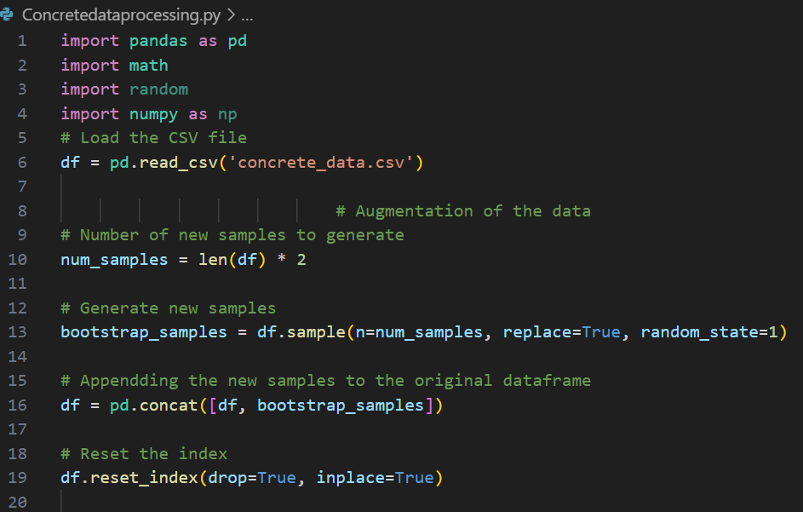

Figure 3. 1 Data Augmentation

In the code above, we first load our dataset from a CSV file. We then determine the number of new samples to generate, which is twice the size of our original dataset. We generate these new samples using the sample function from pandas, which allows us to randomly sample items from our dataset. The replace =True parameter indicates that we are doing bootstrap sampling, i.e., sampling with replacement. This means some samples may be selected more than once, which is what we want for data augmentation.

After generating the new samples, we append them to our original dataframe to get a new dataframe that’s three times the size of our original dataset. Finally, we reset the index of our dataframe to ensure it’s in proper order. This augmented dataset is now ready for further processing and model development.

### **3.5.2 Tensile Strength Calculation**

One of the key steps in our data preprocessing was the calculation of the tensile strength of the concrete samples. Tensile strength is a crucial property of concrete that significantly influences its performance.

To calculate the tensile strength, we used the following formula:

$$Tensile Strength of Concrete= \frac{2 × Maximum Load}{π ×Diameter ×Length}$$

This formula allowed us to compute the tensile strength based on the maximum load that each sample could withstand, and the dimensions of the sample (diameter and length).

To facilitate the calculation process and handle the large volume of data, we utilized Python programming. Python, being a powerful and flexible programming language, made it easier for us to perform these calculations efficiently and accurately.

Here’s a snippet of the Python code we used for the tensile strength calculation:

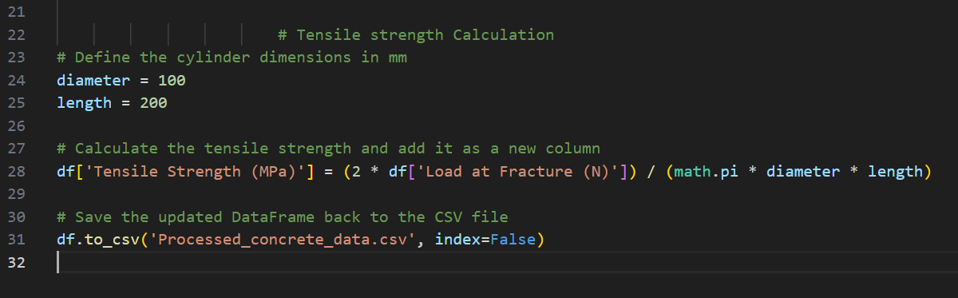

Figure 3. 2 Tensile strength calculation

This code reads the data from a CSV file, calculates the tensile strength for each sample using the formula, and adds these calculations as a new column in the data frame. This streamlined our data preprocessing and ensured that our data was ready for the subsequent stages of our analysis and saved in the Processed_concrete_data.csv file.

## **3.6 DATA ENGINEERING.**

In this section, we focus on preparing our dataset for further analysis and modeling. One of the key steps in this process is handling missing values.

**Handling Missing Values in the ‘Admixtures’ Column**

We observed that the ‘Admixtures’ column in our dataset contains some missing values (NaN). To handle these, we decided to replace all NaN values with the term ‘No Admixture’. This approach is beneficial for a couple of reasons:

1. It allows us to retain these records instead of discarding them, which would lead to loss of information.
2. It simplifies the subsequent encoding process by treating ‘No Admixture’ as another category within the ‘Admixtures’ column.

Here’s the Python code that accomplishes this:

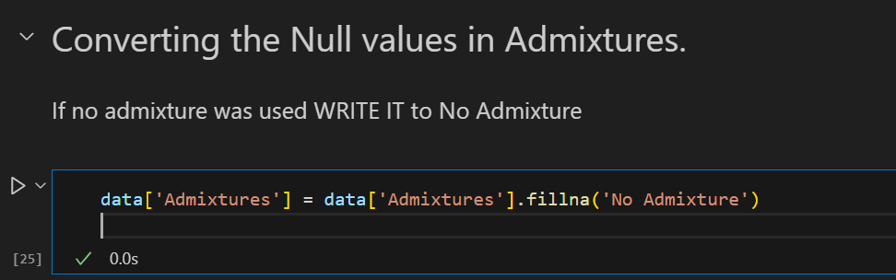

Figure 3. 3 Converting null values of Admixtures

**Checking for Other Missing Values**

After handling the missing values in the ‘Admixtures’ column, we proceed to check if there are any other missing values in the entire dataset. This is an important step to ensure the cleanliness and integrity of our data.

Here’s the Python code that checks for other missing values:

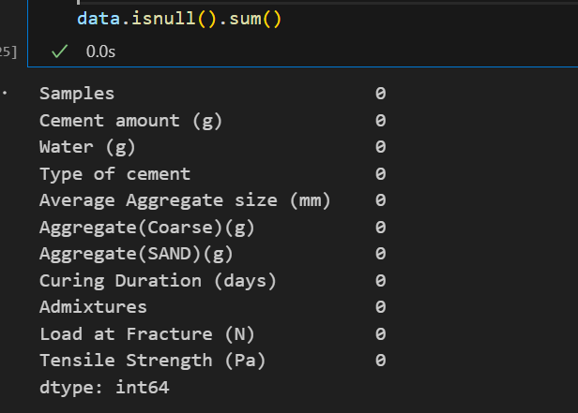

Figure 3. 4 Null values

## **3.7 FEATURE SELECTION.**

In this section, we focus on the process of feature selection, which is a crucial step in building our predictive model for tensile strength.

Feature selection involves choosing the most relevant variables (or ‘features’) from our dataset that contribute to the predictive power of our model. The goal is to improve the model’s performance by reducing overfitting, improving accuracy, and reducing training time.

In our case, we identified certain columns in our dataset that do not significantly contribute to the prediction of tensile strength. These columns are “Samples” and “Load at Fracture (N)”. By eliminating these features from our dataset, we aim to increase the efficiency of our model and enhance its predictive accuracy.

Here’s the Python code that performs this feature selection:

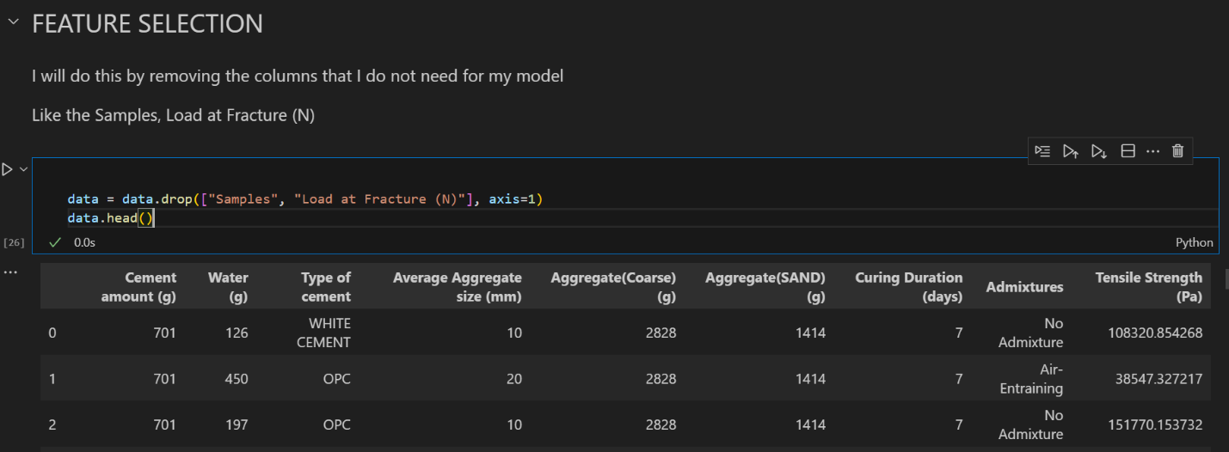

Figure 3. 5 Feature selection

This code removes the “Samples” and “Load at Fracture (N)” columns from our dataset. The data.head() function is then used to display the first few rows of the updated dataset, allowing us to confirm that the specified columns have been successfully dropped.

## **3.8 ENCODING.**

In this section, we focus on encoding our data. Encoding is a process of converting categorical data into numerical data. This step is crucial because machine learning models, including PyTorch models, require numerical inputs and cannot process categorical (string) inputs directly.

We have two categorical variables in our dataset: ‘Type of cement’ and ‘Admixtures’. We use a simple form of encoding known as label encoding, where each unique category value is assigned a unique integer.

Here’s the Python code that performs this encoding:

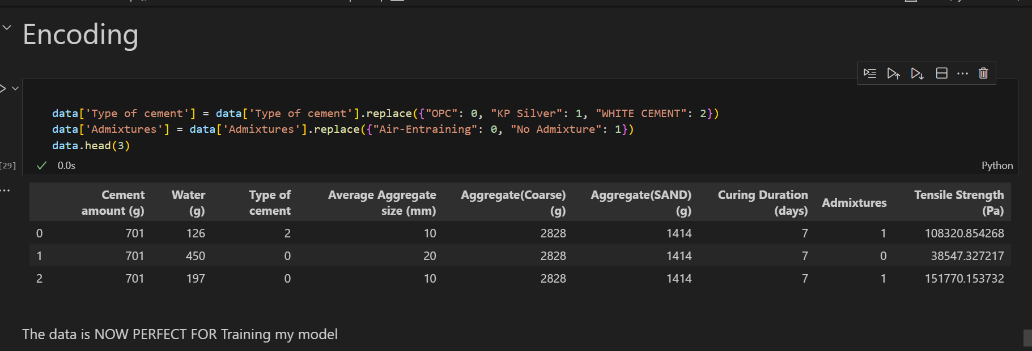

Figure 3. 6 Encoding

In the ‘Type of cement’ column, ‘OPC’ is replaced with 0, ‘KP Silver’ with 1, and ‘WHITE CEMENT’ with 2. In the ‘Admixtures’ column, ‘Air-Entraining’ is replaced with 0, and ‘No Admixture’ with 1.

After encoding, we can confirm the changes by displaying the first few rows of the updated dataset using data.head(). This ensures that our dataset is now ready for training with PyTorch.

## **3.9 SPLITING AND NORMALIZING**

In this section, we focus on two important steps in preparing our data for modeling: splitting and normalizing.

**Data Splitting**

We split our dataset into a training set and a testing set. The training set is used to train our model, while the testing set is used to validate the model’s performance. We use an 80-20 split, meaning 80% of the data is used for training and 20% is used for testing. This allows us to train our model while simultaneously validating its performance.

**Data Normalization**

Before training our model, we normalize our features. Normalization is a scaling technique that adjusts the values of different features to a similar scale. This is important because features might be measured in different units, and we want to ensure that no particular feature dominates others due to its scale. We use the StandardScaler from sklearn.preprocessing to perform this normalization.

**Conversion to PyTorch Tensors**

Finally, we convert our data to PyTorch tensors. Tensors are a generalization of matrices and are used in PyTorch to formulate and solve neural networks. Converting our data to tensors ensures compatibility with PyTorch and prepares our data for the training process.

Here’s the Python code that performs these steps:

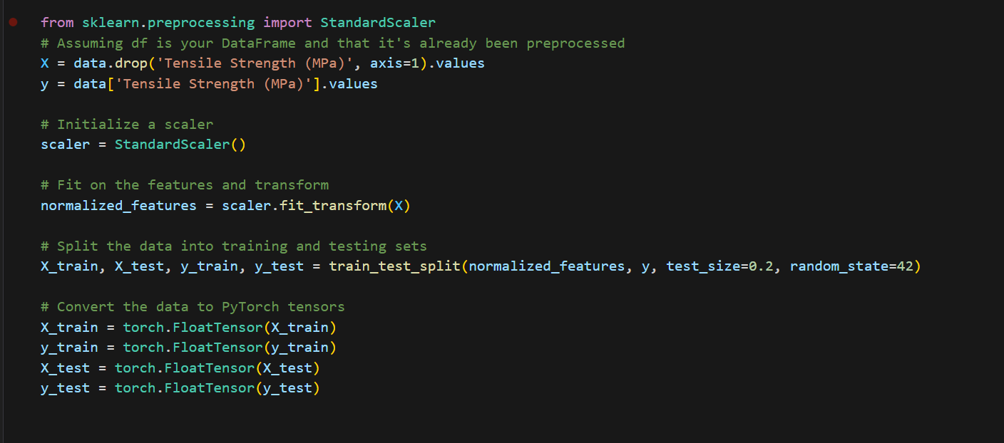

Figure 3. 7 Spliting and Normalization

## **3.10 MODEL DEVELOPMENT**

In this section, we focus on developing our predictive model using the PyTorch library. PyTorch is a popular open-source machine learning library that allows us to build and train neural network models.

Here’s a breakdown of the code:

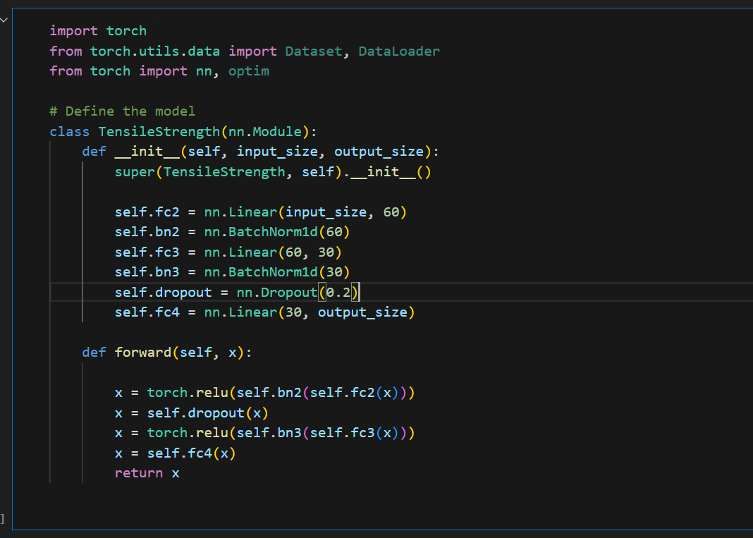

Figure 3. 8 Model

We define a custom PyTorch model class called TensileStrength. This class inherits from nn.Module, which is the base class for all neural network modules in PyTorch.

The TensileStrength class has the following components:

1. **Initialization (**__init__**method)**: This is where the layers of the neural network are defined.
   * self.fc2 = nn.Linear(input_size, 60): This is a fully connected layer (also known as a linear layer) that takes input_size number of inputs and outputs 60 features.
   * self.bn2 = nn.BatchNorm1d(60): This is a batch normalization layer that normalizes the features from the previous layer. It helps in stabilizing the learning process and reduces the number of training epochs required.
   * self.fc3 = nn.Linear(60, 30): Another fully connected layer that takes the 60 features from the previous layer and outputs 30 features.
   * self.bn3 = nn.BatchNorm1d(30): Another batch normalization layer for the features from the previous layer.
   * self.dropout = nn.Dropout(0.2): This is a dropout layer that randomly sets a fraction (0.2 in this case) of input units to 0 at each update during training time, which helps prevent overfitting.
   * self.fc4 = nn.Linear(30, output_size): The final fully connected layer that takes the 30 features from the previous layer and outputs output_size number of outputs.
2. **Forward Propagation (**forward**method)**: This is where the forward pass of the network is defined, i.e., how the network transforms its inputs into outputs.
   * x = torch.relu(self.bn2(self.fc2(x))): The input x is passed through the second fully connected layer, then batch normalization is applied, and then the ReLU (Rectified Linear Unit) activation function is applied. The ReLU function is defined as ReLU(x) = max(0, x), and it introduces non-linearity into the model.
   * x = self.dropout(x): Dropout is applied to the output of the previous layer.
   * x = torch.relu(self.bn3(self.fc3(x))): The output from the dropout layer is passed through the third fully connected layer, then batch normalization is applied, and then the ReLU activation function is applied.
   * x = self.fc4(x): Finally, the output from the previous layer is passed through the fourth fully connected layer to get the final output.

This model structure is a simple feed-forward neural network (also known as a multi-layer perceptron), which is a good starting point for many regression tasks. Depending on the complexity of the task and the data, the model architecture can be further expanded by adding more layers or changing the type of layers.

## **3.11 LOSS FUNCTION AND OPTIMIZATION**

In this section, we focus on defining the loss function and the optimization method for our model. These are crucial components in training a neural network.

Here’s a breakdown of the code:

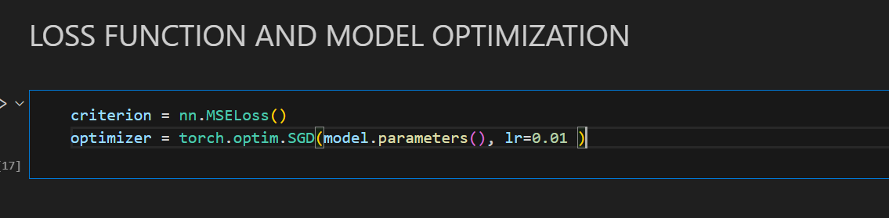

Figure 3. 9 Loss and Optimization

1. **Loss Function (**criterion**)**: The loss function measures how well our model is performing by comparing the model’s predictions with the actual values. In this case, we’re using Mean Squared Error (MSE) loss, which is commonly used for regression problems. MSE calculates the average squared difference between the predicted and actual values, with lower values indicating better model performance.

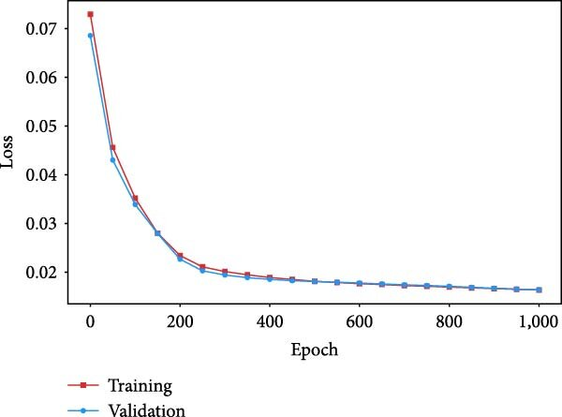

Figure 3. 10 Loss function Curve

The red curve represents the MSE loss between the real proportions and the predicted proportions for the training set in each epoch of training, while the blue curve represents the MSE loss between the real proportions and the predicted proportions for the validation set in each epoch of training.

**2. Optimizer**: In SGD, each parameter p in the model is updated using the following rule:

$$p_{\text{new}}=p_{\text{old}}-\text{lr}*∇_{p}J$$

where:

* p_new is the updated parameter value.
* p_old is the old parameter value before the update.
* lr is the learning rate.
* ∇p J is the gradient of the loss function J with respect to the parameter p.

The gradient ∇p J points in the direction of steepest ascent in the parameter space, and - ∇p J points in the direction of steepest descent. By subtracting a small step in the direction of steepest descent, we hope to decrease the loss function J. This is why the learning rate lr is typically a small positive number, like 0.01 in our code.

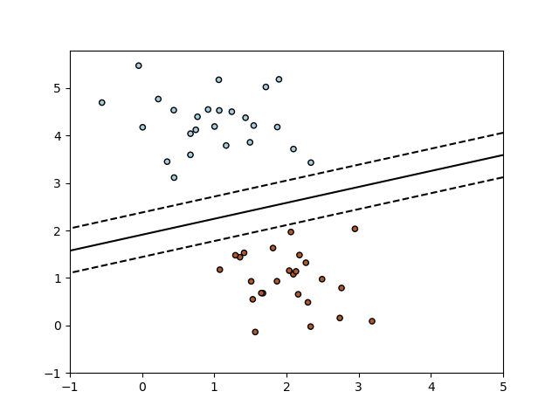

Figure 3. 11 Optimization presentation

The model.parameters() in the optimizer initialization is a call to the parameters of our model (weights and biases), which the optimizer needs to know so it can update them during training.

In summary, the loss function and optimizer work together during the training process to adjust the model’s parameters in a way that minimizes the loss, thereby improving the model’s accuracy. The loss function provides a measure of the model’s performance, and the optimizer uses this measure to adjust the model’s parameters. This process is repeated for a number of iterations (or ‘epochs’) until the model’s performance is satisfactory.

## **3.12 TRAINING**

In the **Model Training** process, we’re teaching our model to make better predictions by gradually adjusting its internal parameters to minimize the loss. It involves running the data through the model (forward pass), calculating the loss, and then updating the model parameters (backward pass and optimization). This process is repeated for a certain number of iterations known as epochs.

Here’s a breakdown of the code:

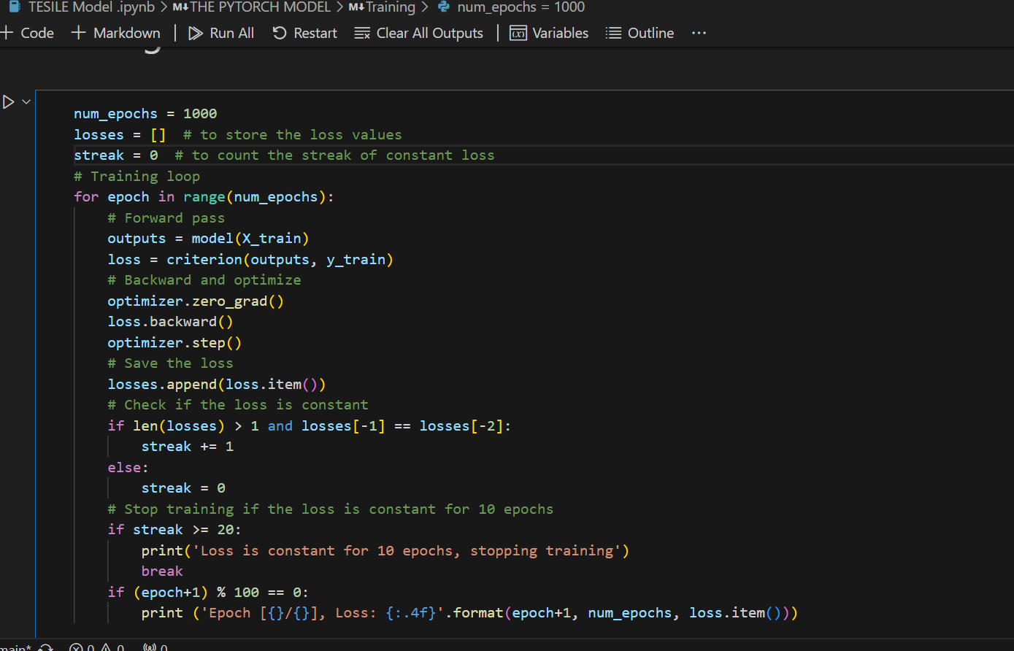

Figure 3. 12 Training

1. **Number of Epochs**: We set the number of epochs to 1000. This means that the entire dataset will be passed forward and backward through the neural network 1000 times. Each repetition is called an “epoch”.
2. **Training Loop**: We start a loop that will iterate for the number of epochs. Inside this loop, we perform several steps:
   * **Forward Pass**: We pass our input data (X_train) through the model. The model returns some output which is stored in the outputs variable.
   * **Calculate Loss**: We then calculate the loss using the criterion we defined earlier (MSE Loss). The loss is calculated by comparing the model’s output (outputs) with the actual target values (y_train). This is our “loss”.
   * **Backward Pass and Optimization**: We first reset all gradients to zero using optimizer.zero_grad(). This is because PyTorch accumulates gradients, and we don’t want to mix up gradients between epochs. We then perform a backward pass using loss.backward(). This computes the gradient of the loss with respect to the model parameters. Finally, we call optimizer.step() to perform an optimization step. This updates the model parameters (weights and biases) using the gradients computed in the backward pass.
3. **Track Loss**: We add the loss for this epoch to our list of losses. We’re setting up a list to keep track of our losses (how far off our predictions are from the actual values) and a counter to keep track of how many times in a row our loss stays the same.
4. **Check Loss**: The next few lines check if the loss has stayed the same for 20 epochs in a row. If it has, we stop the training early because our model isn’t improving.
5. **Print Loss**: Every 100 epochs, we print out the epoch number and the current loss. This helps us monitor the training process and ensure that the loss is decreasing, indicating that our model is learning.

By performing these steps, we train our model to fit our data, adjusting its parameters to minimize the loss and improve its predictive performance. This is a common practice in machine learning to save time and resources.

## **3.13 EVALUATION**

In this section, we focus on evaluating the performance of our trained model. We use two metrics for this purpose: R-squared and Mean Squared Error (MSE).

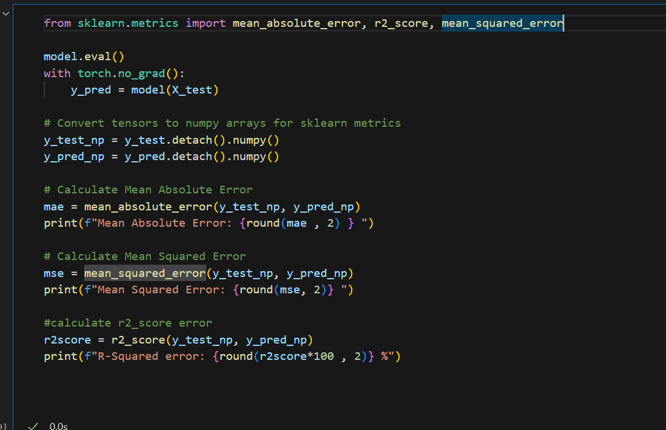

Figure 3. 13 Evaluation with R-squared, Mean absolute error and Mean squared error

This code is evaluating a trained PyTorch model on a test dataset (X_test), and then calculating several metrics to assess the model’s performance. The metrics being calculated are the Mean Absolute Error (MAE), Mean Squared Error (MSE), and R-squared (R²).

**1. Mean Absolute Error (MAE)**: This is the average of the absolute differences between the predicted and actual values. It measures the average magnitude of errors in a set of predictions, without considering their direction. It’s calculated as:

$$MAE=\frac{1}{n}\sum_{i=1}^{n}{}∣y_{i}-{\hat{y}}_{i}∣$$

where yi​ is the actual value, y^​i​ is the predicted value, and n is the number of samples.

**2. Mean Squared Error (MSE)**: This is the average of the squared differences between the predicted and actual values. It puts more weight on large errors because they are squared in the calculation. It’s calculated as:

$$MSE=\frac{1}{n}\sum_{i=1}^{n}{(y_{i}-{\hat{y}}_{i})^{2}}$$

**3. R-squared (R²)**: This is a statistical measure that represents the proportion of the variance for a dependent variable that’s explained by an independent variable or variables in a regression model. It provides a measure of how well the model’s predictions approximate the actual values. It’s calculated as:

$$R^{2}=1-\frac{SS_{res}}{SS_{tot}}$$

where SSres​ is the sum of squares of the residuals (the difference between the actual and predicted values) and SStot​ is the total sum of squares (the difference between the actual values and the mean of actual values). The best possible score for R² is 1.0, which indicates that the model perfectly predicts the actual values.

In the cases, we first set our model to evaluation mode using model.eval(). Then, we use torch.no_grad() to tell PyTorch that we do not want to perform back-propagation, which reduces memory usage and speeds up computation. We then use our model to predict the output for our test data (model(X_test)), and compare these predictions (y_pred) to the actual values (y_test) to compute R-squared and MSE. The results are then printed out. This gives us a quantitative measure of how well our model is performing.

## **3.14 MODEL SAVING.**

In this section, we focus on saving our trained model. Saving a model is important because it allows us to reuse the model later without having to retrain it. This can save a lot of time and computational resources.

Here’s a breakdown of the code:

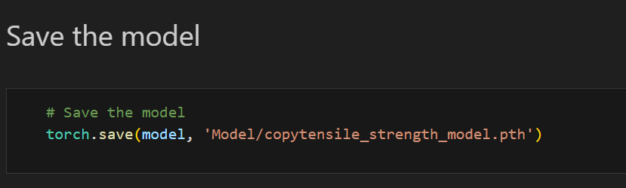

Figure 3. 14 Model Saving

The torch.save() function is used to save the model. This function takes two arguments:

1. The model we want to save (model in this case).
2. The path where the model should be saved ('Model/copytensile_strength_model.pth' in this case).

The .pth extension is commonly used for PyTorch models.

After running this code, the trained model is saved to the specified path. You can load this model later using the torch.load() function and use it for making predictions, without having to retrain the model. This is particularly useful when model training is time-consuming or computationally expensive. This will save the entire model, which includes both the architecture and the learned parameters (weights and biases).

## **3.15 MODEL PREDICTION.**

In this section, we focus on making predictions with our trained model. The prediction process is divided into two main parts: data collection and model prediction.

### **3.15.1 Data Collection**

The first part involves collecting the data that we want to make predictions on. To make this process user-friendly, we create a Graphical User Interface (GUI) using the tkinter library in Python. This GUI allows users to input the data in a clean, professional, and pleasant manner.

Here’s a breakdown of the code:

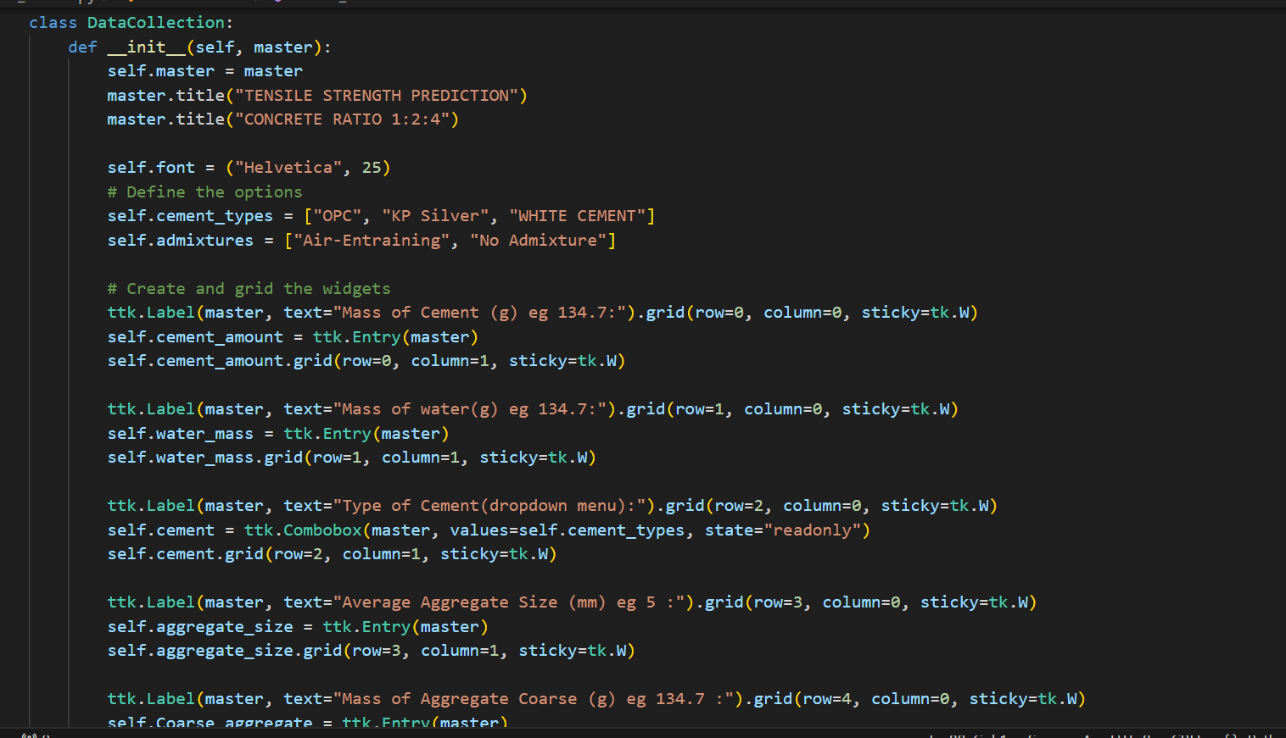

Figure 3. 15 Code for asking the user for data so as to use the data in in prediction

We define a class DataCollection that creates a GUI for data input. The GUI includes fields for entering various parameters like ‘Cement amount (g)’, ‘Water (g)’, ‘Type of cement’, etc. Each field is created using ttk.Entry for text input or ttk.Combobox for dropdown selection.

When the ‘Submit’ button is clicked, the collect_data method is called. This method collects the data from all the input fields and stores it in a dictionary called data. This data can then be used for making predictions with our model.

### **3.15.2 Predictions**

In this section, we focus on making predictions with our trained model. The process involves data processing, normalization, loading the trained model, making a prediction, and displaying the predicted tensile strength on the GUI.

Here’s a breakdown of the code:

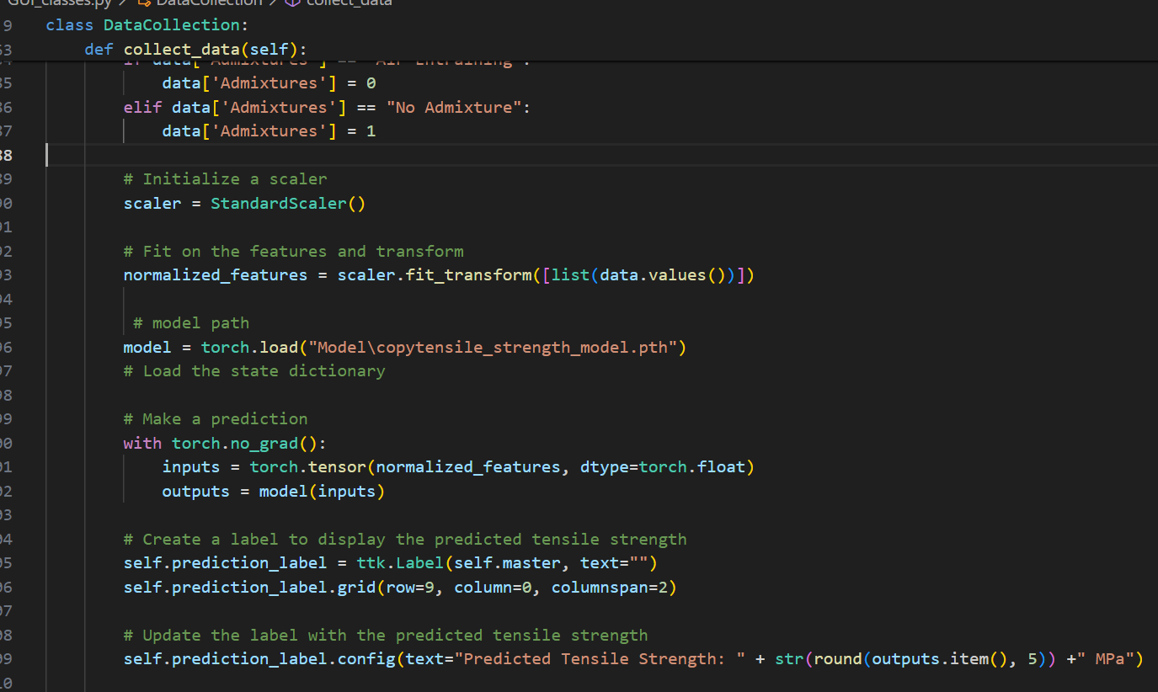

Figure 3. 16 Prediction

1. **Data Processing**: The categorical variables ‘Type of cement’ and ‘Admixtures’ are converted into numerical form. This is necessary because machine learning models require numerical inputs.
2. **Normalization**: The data is then normalized using the StandardScaler from sklearn.preprocessing. Normalization is a scaling technique that adjusts the values of different features to a similar scale. This is important because features might be measured in different units, and we want to ensure that no particular feature dominates others due to its scale.
3. **Load the Trained Model**: The trained model is loaded from the specified path using torch.load().
4. **Make a Prediction**: The normalized data is converted into a PyTorch tensor and passed through the model to get the predicted tensile strength.
5. **Display the Prediction**: A label is created on the GUI to display the predicted tensile strength. The label is updated with the predicted value.
6. **Print the Data and Prediction**: The processed data and the predicted tensile strength are printed to the console. This is optional and can be useful for debugging or logging purposes.

It’s crucial to note that all data preprocessing for the prediction phase is performed in the same manner as during the training phase. This consistency is vital to ensure that the input data for prediction aligns with what the model expects based on its training. Any discrepancies in data preprocessing between the training and prediction phases could lead to confusion for the model and potentially result in inaccurate predictions. Therefore, maintaining uniformity in data preprocessing is a key aspect of reliable model performance.

In summary, this process allows us to collect data in a user-friendly way, process and normalize the data, make predictions using our trained model, and display the predictions in a clear and understandable manner.

### **3.15.3 Making Predictions**

In this section, we focus on making predictions with our trained model. To facilitate this process, we utilize a Graphical User Interface (GUI) for data input and prediction display. The GUI is designed to provide a user-friendly experience, ensuring a smooth prediction process.

Here’s a breakdown of the code:

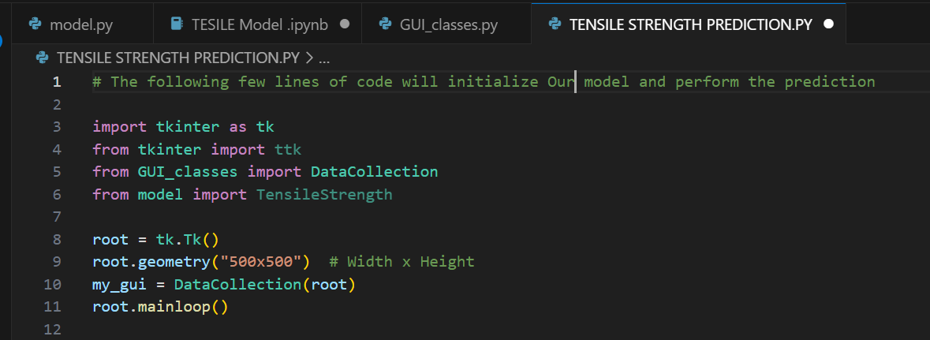

Figure 3. 17 prediction by using code to initialize the saved model

1. **Import Necessary Libraries and Modules**: We import the necessary libraries (tkinter and ttk) and modules (DataCollection and TensileStrength) for creating the GUI and making predictions.
2. **Initialize Tkinter Window**: We create a Tkinter window (root) and set its size to 500x500 pixels using root.geometry("500x500").
3. **Initialize Data Collection GUI**: We create an instance of the DataCollection class (my_gui), passing the root window as an argument. This initializes the data collection GUI on our window.
4. **Start Tkinter Event Loop**: Finally, we start the Tkinter event loop using root.mainloop(). This starts the GUI and waits for user interaction.

By running this code, we initialize our data collection GUI and are ready to collect data, make predictions using our trained model, and display the predictions in a clear and understandable manner. The GUI provides a clean and professional interface for users to interact with the model and obtain predictions. It simplifies the prediction process and enhances the user experience.

# **CHAPTER FOUR**

# **4.0 RESULTS, ANALYSIS AND DISCUSSION**

In this section, we delve into the outcomes of our study, providing a comprehensive examination and interpretation of the results. We aim to link our findings to our initial objectives and hypotheses, discussing their implications in a broader context.

## **4.1 INTRODUCTION.**

The purpose of this introductory subsection is to set the stage for the detailed discussion that follows. We will revisit the objectives of our study, briefly summarize the methods employed, and provide an overview of the main results. This will facilitate a deeper understanding as we proceed with a thorough analysis and discussion of our findings, their significance, and their potential impact. We will also address any limitations encountered during the study and propose directions for future research.

## **4.2 DATA COLLECTION.**

During the data collection phase of our study, we encountered several challenges. One of the primary obstacles was the lack of funding to purchase more admixtures, which limited the amount of data we could collect. Despite this constraint, we managed to augment our dataset using a technique known as bootstrapping.

Bootstrapping is a statistical method that involves resampling a dataset with replacement. It allowed us to effectively double our data from 27 samples to 81 samples. This method was particularly efficient for our data because it allowed us to maximize the use of our limited resources and generate a larger and more diverse dataset for our model to learn from.

However, it’s important to note that while bootstrapping can be a useful tool in certain situations, it’s not always the most efficient method for acquiring data. It essentially creates synthetic data, which may not capture the full complexity and variability of real-world data. Therefore, the results obtained from a model trained on bootstrapped data should be interpreted with caution.

Another limiting factor in our data collection process was time. The process of preparing the samples, conducting the experiments, and collecting the data was time-consuming. This further constrained the amount of data we could collect.

Despite these challenges, we were able to collect a dataset that included variables such as ‘Cement amount (g)’, ‘Water (g)’, ‘Type of cement’, ‘Average Aggregate size (mm)’, ‘Curing Duration (days)’, ‘Admixtures’, and ‘Load at Fracture (N)’. This data served as the foundation for our subsequent analysis and model development.

## **4.2 DATA PROCESSING.**

In this section, we focused on preparing our dataset for model development. This involved several key steps:

1. **Handling Missing Values**: During the data collection phase, we encountered a lack of sufficient admixtures to use in sample preparation. This resulted in missing values in our dataset. To handle these missing values, we replaced them with the term ‘No Admixture’. This approach allowed us to retain these records instead of discarding them, which would lead to loss of information.
2. **Encoding**: After handling the missing values, we proceeded to encode our data. Encoding is a process of converting categorical data into numerical data. This step is crucial because machine learning models require numerical inputs. In our case, we converted the ‘No Admixture’ and ‘Air-Entraining’ categories in the ‘Admixtures’ column into numerical form.
3. **Normalization**: Finally, we normalized our data using the StandardScaler method from the sklearn.preprocessing library in Python. Normalization is a technique used to change the values of numeric columns in the dataset to use a common scale, without distorting differences in the ranges of values or losing information. In our case, we scaled the data to a range between 0 and 1. Normalization is important when the dataset contains features that are on different scales and can help improve the performance of the machine learning model.

By performing these steps, we ensured that our dataset was clean, properly formatted, and ready for model development. These preprocessing steps are crucial in any machine learning project and can significantly impact the performance of the final model.

## **4.3 EFFECT ON TENSILE STRENGTH.**

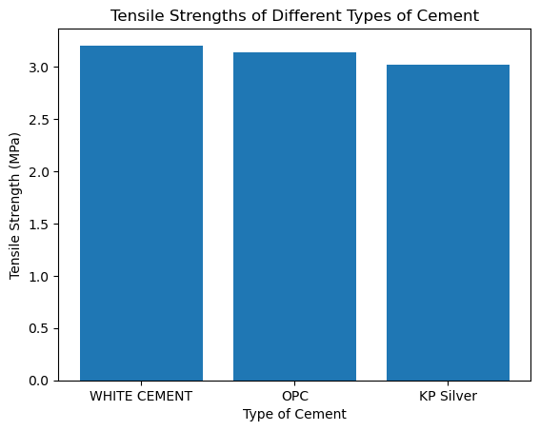

Figure 4. 1 Tensile Strength of Diffrent Types of Cement

The data demonstrates a consistent tensile strength of 3.0 MPa across three different types of cement: WHITE CEMENT, OPC, and KP Silver. This uniformity suggests that the volume of cement used significantly affects the tensile strength of the concrete. Furthermore, the equal distribution of data across the three types of cement indicates their consistent performance in contributing to the tensile strength of the concrete.

## **4.4 THE MODEL.**

### **4.4.1 Model Development**

This model is a type of artificial neural network, which is a computing system inspired by the biological neural networks that constitute animal brains. It’s built using the PyTorch library, a popular open-source machine learning library for Python.

The model summary provides a clear picture of our model’s architecture:

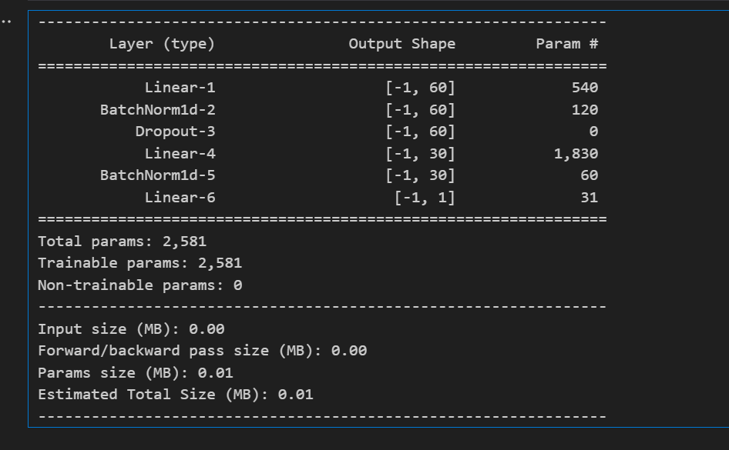

Figure 4. 2 Model Architecture

1. **Linear-1**: This is a fully connected layer (also known as a dense layer), where each input node (or neuron) is connected to each output node. It has 60 output nodes. The number of input nodes is not shown here, but it would match the number of features in the input data. The layer has 540 parameters, which are the weights and biases that the model will learn through training.
2. **BatchNorm1d-2**: This is a batch normalization layer. It normalizes the output of the previous layer to stabilize the learning process and reduce the number of training steps required. It has 60 output nodes, matching the number of output nodes in the previous layer. It has 120 parameters, which are used to scale and shift the normalized output.
3. **Dropout-3**: This is a dropout layer, which helps prevent overfitting. During training, it randomly sets a fraction of its input nodes to 0 at each update, which helps prevent overfitting.
4. **Linear-4**: This is another fully connected layer, this time with 30 output nodes. It has 1,830 parameters.
5. **BatchNorm1d-5**: This is another batch normalization layer, this time normalizing the 30 outputs of the previous layer. It has 60 parameters.
6. **Linear-6**: This is the final fully connected layer, with just 1 output node, since this is a regression model that predicts a single continuous value. It has 31 parameters.

The total number of parameters in the model is 2,581. These are the values that the model will learn through training to minimize the difference between its predictions and the actual values.

The “Input size”, “Forward/backward pass size”, “Params size”, and “Estimated Total Size” are all measures of how much memory the model requires.

Finally, we initialize our model with this line of code:

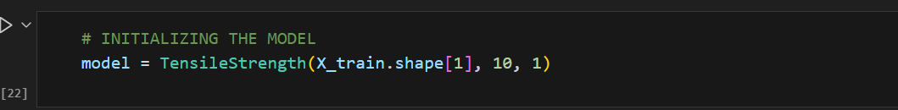

Figure 4. 3 Model initialization

This line of code breathes life into our TensileStrength model, preparing it to be trained on our data (X_train) and make predictions. The numbers inside the parentheses inform the model about the number of inputs it should expect, the number of hidden units to have, and the number of outputs to produce. In this case, it expects as many inputs as there are features in X_train, it has 10 hidden units, and it produces 1 output (the predicted tensile strength).

### **4.4.2 Model Training.**

In this phase, we discovered that when the model was trained for a few epochs (iterations), it experienced a significant loss. However, as we increased the number of epochs, the model’s performance improved. This improvement is evident in the decreasing loss shown in the training graph after each epoch.

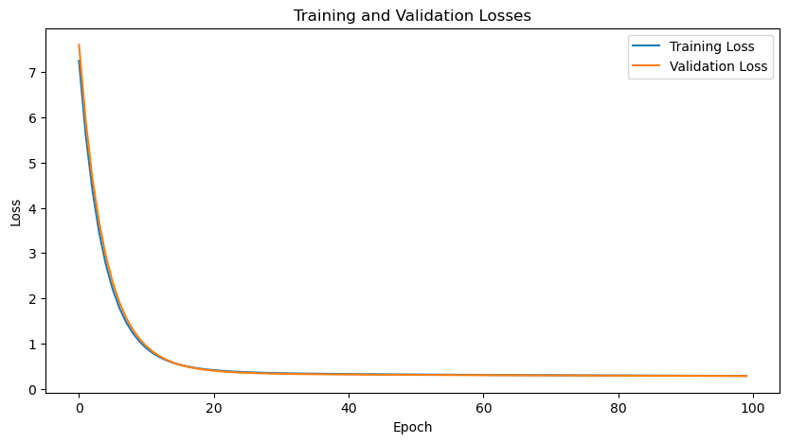

Figure 4. 4 Learning Curve Losses against Epoch on training vs Validation

This graph is showing the training and validation losses of a machine learning model over a number of training epochs. An epoch is one complete pass through the entire training dataset.

* The **blue line** represents the **training loss**, which is the error of the model on the data it is learning from. You can see that as the number of epochs increases, the training loss decreases. This is because the model is adjusting its parameters (or learning) to minimize this loss.
* The **orange line** represents the **validation loss**, which is the error of the model on new, unseen data. The validation loss decreasing for some time and then becoming almost constant indicates that the model is generalizing well to new data up to a point, but after that point, even though the model is getting better on the training data (training loss is decreasing), it is not showing significant improvement on the validation data.

The x-axis represents the number of epochs, and the y-axis represents the loss. The loss is a measure of how well the model’s predictions match the actual values. Lower loss values are better, as they indicate that the model’s predictions are close to the actual values.

This kind of plot is very useful in machine learning because it helps us understand if our model is learning properly. If the training loss continues to decrease significantly while the validation loss increases, it could be a sign that the model is overfitting, or learning the training data too well and not generalizing to new data. In this case, the model seems to be performing well as both the training and validation losses are decreasing and stabilizing.

We used the nn.MSELoss function and the Stochastic gradient descent optimizer to enhance the training process. The nn.MSELoss function measures the mean squared error (a common loss function) between each element in the input and target, while the Stochastic gradient descent optimizer is an algorithm for first-order gradient-based optimization of stochastic objective functions.

However, our journey was not without its challenges. One significant hurdle was training the parameters to properly understand the data. When we added more hidden layers to the model, we discovered that the model was overfitting due to insufficient training data. Overfitting is a modeling error that occurs when a function is too closely aligned to a limited set of data points.

Additionally, our local machine kept running out of processing space; the RAM was small. This issue arose every time we made the model complex to improve performance. We could have overcome this challenge if we had funding to pay for a dedicated GPU on either Google Colab or Microsoft Azure’s platforms for training our model.

We used the free Google Colab, but it was limited, so we ended up simplifying the model. This resulted in a 20% accuracy prediction, which, while low, is a stepping stone towards improving our model’s performance. Despite these challenges, we remained committed to refining the model and enhancing its predictive accuracy.

The model’s performance was improved when we normalized the data. Normalization is a technique often applied as part of data preparation for machine learning. The goal of normalization is to change the values of numeric columns in the dataset to use a common scale, without distorting differences in the ranges of values or losing information.

In this section, the model architecture was rebuilt a few times to improve the model until we couldn’t improve it further using the limited resources we had. This iterative process of building and refining the model is a common practice in machine learning and is crucial for achieving the best possible performance.

## **4.5 EVALUATION**

This is the stage where we assess the performance of our model.

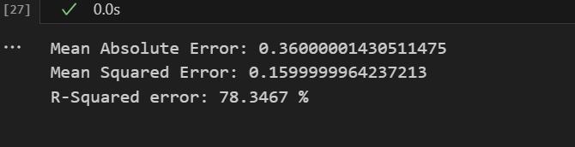

Figure 4. 5 Evaluation

* The **Mean Absolute Error (MAE)** of 0.36 suggests that on average, our model’s predictions are about 0.36 units away from the actual values. This gives us an idea of the average error we might expect on unseen data.
* The **Mean Squared Error (MSE)** of 0.16 is quite low, which is a good sign. MSE is sensitive to larger errors, so a low MSE suggests that our model doesn’t make very large errors often.
* The **R-squared (R²)** value of 78.35% means that our model’s predictions explain about 78.35% of the variance in the tensile strength of concrete. This is a fairly high R² value, suggesting that our model has learned a significant amount of the pattern in our data.

while these metrics can give us a good idea of our model’s performance, it’s also important to visually inspect our model’s predictions (for example, by plotting predicted vs actual values), and to test our model on a separate test set to ensure it generalizes well to new, unseen data.

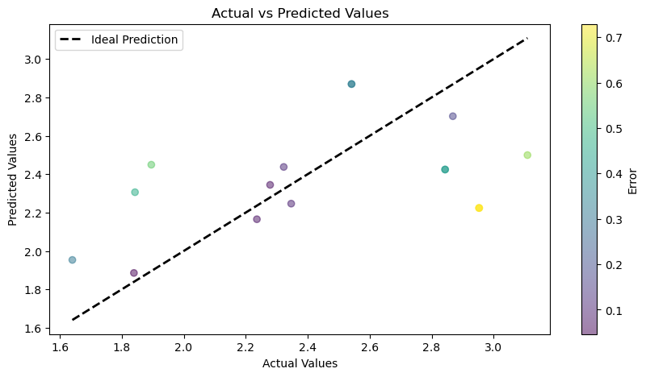

Figure 4. 6 Actual vs Predicted values

In the scatter plot shared, we can see the performance of a machine learning model that predicts the tensile strength of concrete. The plot compares the actual tensile strength values (represented on the x-axis) with the values predicted by the model (represented on the y-axis). Each point on the plot corresponds to a specific sample from the test set, with its position indicating the actual and predicted values for that sample.

The dashed line labeled “Ideal Prediction” in the plot represents a scenario where every prediction made by the model perfectly matches the actual value. In such a case, all points would lie on this line.

However, in practice, it’s normal for predictions to deviate from actual values. This deviation is represented by the distance of each point from the “Ideal Prediction” line. Points above the line indicate instances where the model overestimated the tensile strength, while points below the line indicate instances where the model underestimated the tensile strength.

The color of the points provides a visual representation of the magnitude of the error, with purple indicating small errors and yellow indicating larger errors.

From the plot, it appears that the model is performing reasonably well. Most of the points are relatively close to the “Ideal Prediction” line, indicating that the model’s predictions are generally close to the actual values. The colors of the points suggest that the errors are relatively small, although there are a few points with larger errors, as indicated by the yellow color.

This kind of plot is a valuable tool for visualizing the performance of the model.

## **4.6 TESTING**

After evaluating our model, we wanted to test it further to see how well it performs on new data. So, we collected additional data from 3 extra samples that we had. The goal was to see how accurately our model can predict the tensile strength for these samples.

We have a table here that shows the actual tensile strength (in MPa) of each sample and what our model predicted:

Table 4. 1 Three Lab Sample testing results

|  |  |  |  |  |
| --- | --- | --- | --- | --- |
| Sample | Actual Tensile Strength (MPa) | Predicted Tensile Strength (MPa) | Percentage Change (%) | Percentage Accuracy (%) |
| 1 | 3.04 | 2.04123 | 32.89 | 67.11 |
| 2 | 2.01 | 1.61632 | 19.56 | 80.44 |
| 3 | 2.21 | 1.72041 | 22.15 | 77.85 |

From our observations, the model demonstrates an average accuracy of **75.13%**, which signifies its effectiveness. The model appears to have generalized well with our dataset, although there are noticeable discrepancies between the actual and predicted values. These differences suggest that while our model has successfully identified certain patterns within the training data, it isn’t flawless and there’s potential for enhancement. This could be attributed to a variety of factors, one of which might be the insufficiency of training data for the model to learn optimally.

The complete data and predictions are provided in Appendix IV. This testing phase is crucial in machine learning as it helps us understand how our model would perform in the real world on unseen data. It’s a good practice to always test your model with new data before drawing conclusions about its performance.

# **CHAPTER FIVE**

## **5.0 CONCLUSION AND RECOMENDATION**

## **5.1 DATA COLLECTION PROCESS**

In conclusion, the process of data collection was a crucial part of our project. We were able to gather diverse data and document it effectively in a .csv file using Microsoft Excel software. The cleanliness and accuracy of the data were paramount as they directly influenced the performance of our model.

The data collection process involved gathering data on various factors that influence tensile strength. We used three types of cement for our experiments. Our findings underscored the importance of having a variety of data. If we had included more types of cement in our data, we could have generated a more comprehensive and efficient dataset.

However, we faced some challenges during data collection. Time was a limiting factor, which restricted the amount of data we could collect. Additionally, we only used one type of admixture in our experiments, which could have limited the diversity of our data.

Based on our experience, we recommend the following for future work:

1. **Expand the Variety of Data**: Including more types of cement and admixtures in the data could lead to a more robust and accurate model.
2. **Invest More Time in Data Collection**: Allocating more time for data collection could allow for a more comprehensive dataset, leading to a more reliable model.
3. **Ensure Availability of Materials**: The availability of materials is crucial for data collection. Ensuring a steady supply of materials can prevent interruptions in the data collection process.

In summary, while our model’s performance was satisfactory given the data we had, there is potential for improvement. By expanding the variety of data and investing more time in data collection, future work could yield a more accurate and reliable model. Despite the challenges faced, our commitment to refining our model and enhancing its predictive accuracy remains unwavering. We believe that with these recommendations, future work can build upon our findings and achieve even better results.

## **5.2 MODEL PREDICTION ON NEW DATA**

Our model was put to the test with new data, and despite facing certain limitations, it demonstrated a commendable performance with an accuracy of 78.13%. The constraints we encountered were primarily due to a small dataset and a basic PyTorch model, both of which were the result of limited funds for procuring a GPU runtime from platforms like Google Colab or Microsoft Azure. Given more resources, we could have constructed a more intricate model that would have better comprehended the subtleties in our limited dataset.

The scarcity of data posed a significant challenge for our model. In the realm of machine learning, the volume and quality of data directly influence the model’s performance. A more diverse and representative dataset would have enabled our model to learn more effectively and yield more accurate predictions.

Despite these hurdles, the model’s prediction of the three new samples was quite satisfactory, indicating its ability to generalize from the training data to unseen data to a certain extent.

In conclusion, while our model exhibited promising results on the new data, there is potential for enhancement. Future endeavors should concentrate on gathering more data and possibly investing in additional computational resources to develop a more sophisticated model. Despite the challenges encountered, our dedication to refining our model and boosting its predictive accuracy remains steadfast. We are confident that with these improvements, our model can serve as a foundational base for more complex and precise Tensile Strength Predictive models. This study underscores the importance of independent evaluation of tensile strength in concrete and provides a practical approach for creating durable structures.

## **5.3 RECOMMENDATION**

Based on our project, we highly recommend the adoption and further improvement of this model in Kenya. The model, which predicts the tensile strength of cement, has shown promising results despite the limitations faced during data collection and model training.

The data collection process was meticulous and effective, resulting in a diverse dataset. However, expanding the variety of data, particularly the types of cement and admixtures, could lead to a more robust and accurate model. Additionally, investing more time in data collection and ensuring the availability of materials could prevent interruptions in the data collection process and allow for a more comprehensive dataset.

The model’s performance on new data was quite good, indicating its ability to generalize from the training data to unseen data. However, there is room for improvement. Future work should focus on acquiring more data and potentially investing in more computational resources to build a more complex model. This would allow the model to understand the nuances in the dataset better and improve its predictive accuracy.

In conclusion, despite the challenges faced, this project has laid a solid foundation for a more complex and accurate Tensile Strength Predictive model. With these improvements, we believe the model can be a valuable tool for the construction industry in Kenya, enhancing the quality of constructions and contributing to the country’s development. We remain committed to refining our model and enhancing its predictive accuracy, and we believe that with continued effort and resources, this model can achieve even better results.

# **REFFERENCE**

1. ASTM C496-11. (2011). Standard Test Method for Split Tensile Strength of Cylindrical Concrete Samples. *American Society for Testing and Materials*.
2. ASTM C150-07. (2007). Standard specification for Portland cement. *American Society for Testing and Materials*.
3. Weerheijm, J. (2013). Understanding the Tensile Properties of Concrete. *Woodhead Publishing Series in Civil and Structural Engineering*. Elsevier Science. ISBN 0857097539, 9780857097538.
4. Wendner, L. W. (2022). The deterministic relationship of concrete tensile strength and compressive strength. *Construction and Building Materials, 420*.
5. What are Neural Networks? | IBM. Retrieved from <https://www.ibm.com/topics/neural-networks>.
6. Explained: Neural networks | MIT News | Massachusetts Institute of Technology. Retrieved from <https://news.mit.edu/2017/explained-neural-networks-deep-learning-0414>.
7. Build the Neural Network — PyTorch Tutorials 2.1.1+cu121 documentation. Retrieved from <https://pytorch.org/tutorials/beginner/basics/buildmodel_tutorial.html>.
8. Defining a Neural Network in PyTorch. Retrieved from <https://pytorch.org/tutorials/recipes/recipes/defining_a_neural_network.html>.
9. How neural networks work - A simple introduction - Explain that Stuff. Retrieved from <https://www.explainthatstuff.com/introduction-to-neural-networks.html>.
10. A Simple Neural Network Classifier using PyTorch, from Scratch. Retrieved from <https://medium.com/analytics-vidhya/a-simple-neural-network-classifier-using-pytorch-from-scratch-7ebb477422d2>.
11. Bagher Shemirani, A., & Lawaf, M.P. (2023). Prediction of tensile strength of concrete using the machine learning methods. *Asian J Civ Eng*.
12. Deep Neural Networks with PyTorch | Coursera. Retrieved from <https://www.coursera.org/learn/deep-neural-networks-with-pytorch>.
13. GitHub - pytorch/pytorch: Tensors and Dynamic neural networks in Python. Retrieved from <https://github.com/pytorch/pytorch>.
14. Concrete compressive strength using artificial neural networks. Retrieved from <https://link.springer.com/article/10.1007/s00521-019-04663-2>.
15. Prediction of concrete strength using response surface function. Retrieved from <https://journals.plos.org/plosone/article?id=10.1371/journal.pone.0285746>.
16. Predicting the indirect tensile strength of self-compacting concrete. Retrieved from <https://koreascience.kr/article/JAKO201330360975593.page>.
17. Predicting Compressive Strength of Self-Repairing Concrete. Retrieved from <https://link.springer.com/chapter/10.1007/978-981-99-6774-2_44>.
18. Engineeringenotes.com. (n.d.). Compressive and Tensile Strength of Concrete: Relation | Concrete Technology. Retrieved April 25, 2024.
19. Civil-engg-world.com. (2020, January 6). Relation between Compressive and Tensile Strength of Concrete. Retrieved April 25, 2024.
20. Springer. (n.d.). Concrete Technology. Retrieved April 25, 2024.

# **APPENDICES**

## **APPENDIX I WORK PLAN**

Appendices Table 1 Work Plan

|  |  |  |  |  |  |  |  |  |  |  |
| --- | --- | --- | --- | --- | --- | --- | --- | --- | --- | --- |
| MONTH | OCTOBER  2023 | NOVEMBER  2023 | DECEMBER  2023 | JANUARY  2024 | FEBRUARY  2024 | MARCH 2024 | | | | APRIL  2024 |
| WEEK |  |  |  |  |  | 1 | 2 | 3 | 4 |  |
| Selection of the project |  |  |  |  |  |  |  |  |  |  |
| Introduction |  |  |  |  |  |  |  |  |  |  |
| Literature review |  |  |  |  |  |  |  |  |  |  |
| Methodology and expected results |  |  |  |  |  |  |  |  |  |  |
| Final Project proposal presentation |  |  |  |  |  |  |  |  |  |  |
| Project Research |  |  |  |  |  |  |  |  |  |  |
| Material Gathering |  |  |  |  |  |  |  |  |  |  |
| Project Progress Presentation 2 |  |  |  |  |  |  |  |  |  |  |
| Data Collection |  |  |  |  |  |  |  |  |  |  |
| Model Development |  |  |  |  |  |  |  |  |  |  |
| Model Training |  |  |  |  |  |  |  |  |  |  |
| Model Prediction |  |  |  |  |  |  |  |  |  |  |
| Documentation |  |  |  |  |  |  |  |  |  |  |
| FINAL PRESENTATION |  |  |  |  |  |  |  |  |  |  |

## 

## **APPENDIX II BUDGET**

Appendices Table 2 Budget

|  |  |  |
| --- | --- | --- |
| **MATERIAL** | | **TOTAL COST** |
| Cement | KP Silver | 2000 |
| White cement | 2000 |
| Transportation | | 2500 |
| Miscellaneous | | 3000 |
| **TOTAL** | | **9500** |

## **APPENDIX III EXPERIMENTAL DATA**

### **APPENDIX A - Data collected.**

Appendices Table 3 Experimental data Sample of data collected

|  |  |  |  |  |  |  |  |  |  |  |
| --- | --- | --- | --- | --- | --- | --- | --- | --- | --- | --- |
| Samples | Cement amount (g) | Water (g) | Type of cement | Average Aggregate size (mm) | Aggregate (Coarse)  (g) | Aggregate (SAND) (g) | Curing Duration (days) | Admixtures | Load at Fracture (N) | |
| 1 | 701 | 285 | WHITE CEMENT | 20 | 2828 | 1414 | 7 | Air-Entraining | 80534 |
| 2 | 701 | 500 | OPC | 20 | 2828 | 1414 | 7 |  | 73328 |
| 3 | 701 | 388 | KP Silver | 10 | 2828 | 1414 | 7 |  | 55743 |
| 4 | 701 | 112 | KP Silver | 20 | 2828 | 1414 | 7 | Air-Entraining | 94747 |

## **APPENDIX IV LAB SAMPLE PREDICTION**

### **APPENDIX A – THE TABLE**

Appendices Table 4 The 3 data samples for prediction

|  |  |  |  |  |  |  |  |  |  |  |
| --- | --- | --- | --- | --- | --- | --- | --- | --- | --- | --- |
| Samples | Cement amount (g) | Water (g) | Type of cement | Average Aggregate size (mm) | Aggregate (Coarse) (g) | Aggregate (SAND) (g) | Curing Duration (days) | Admixtures | LAB  Tensile Strength (MPa) | Predicted Tensile Strength (MPa) |
| A | 701 | 453 | WHITE CEMENT | 5 | 2828 | 1414 | 7 | Air-Entraining | 3.047115 | 2.04123 |
| B | 701 | 638 | KP Silver | 20 | 2828 | 1414 | 7 | No Admixture | 2.013026 | 1.61632 |
| C | 701 | 530 | OPC | 10 | 2828 | 1414 | 7 | Air-Entraining | 2.21254 | 1.72041 |

### **APPENDIX B – Sample A prediction**

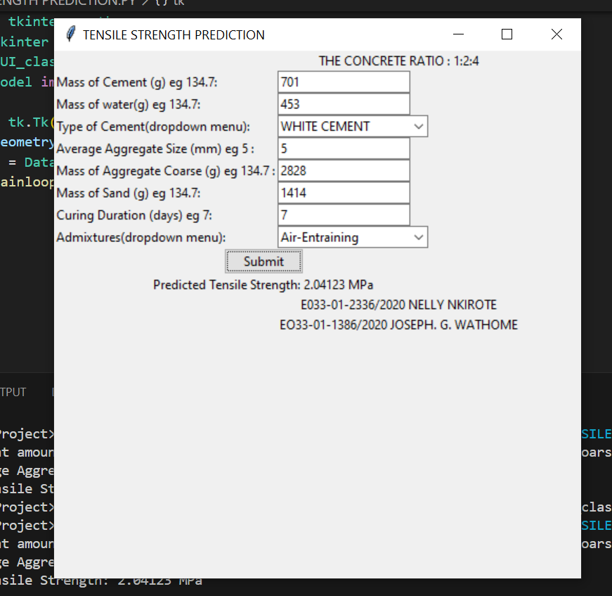

Appendix 1 Sample A Prediction

### **APPENDIX C – Sample B prediction**

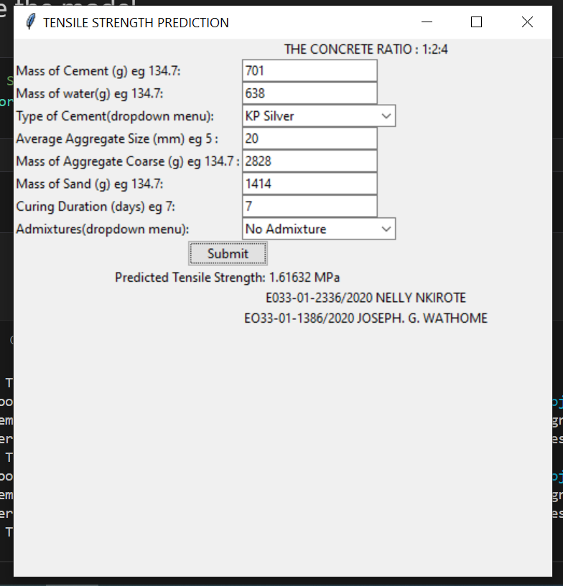

Appendix 2 Sample B Prediction

### **APPENDIX D – Sample C prediction**

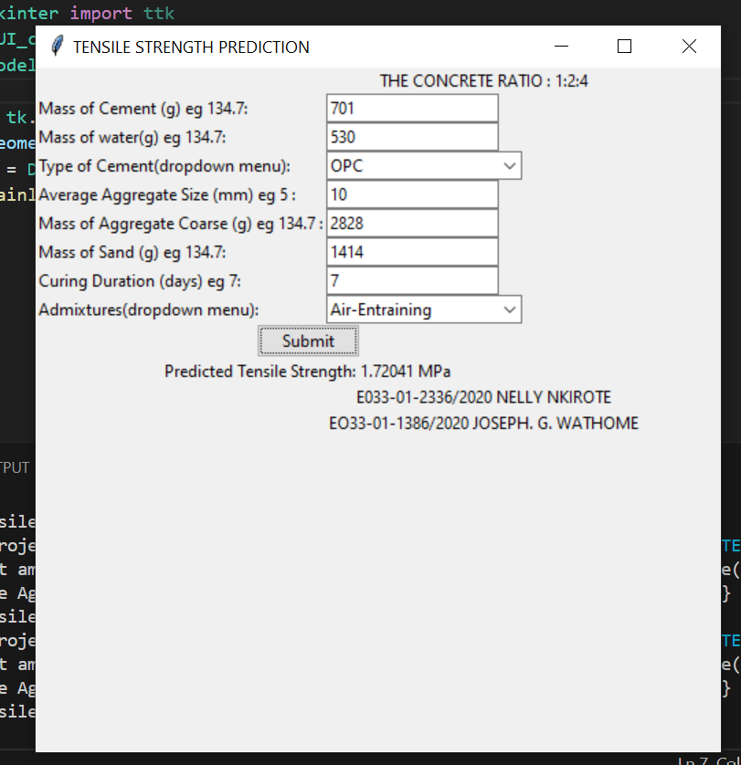

Appendix 3 Sample C Prediction

## **APPENDIX V MODEL IN USE VIDEO LINK**

Link to the video showcasing the Model in action: <https://drive.google.com/file/d/1G1Mc1i4VIM-s8zdNwwrHbDqwgwbBxFDh/view?usp=sharing>

## **APPENDIX VI SOURCE CODE FOR THE MODEL**

The following link is a Github repository that showcases our source code, Data and files: <https://github.com/Josewathome/Tensile-Prediction-Model>

## **APPENDIX VII PICTURES**



Appendix 4 Example of Cement used the White Portland Cement



Appendix 5 Us preparing and casting the samples



Appendix 6 Removing the samples from cast so as to Cure the samples



Appendix 7 Examples of samples from the Curing Drum

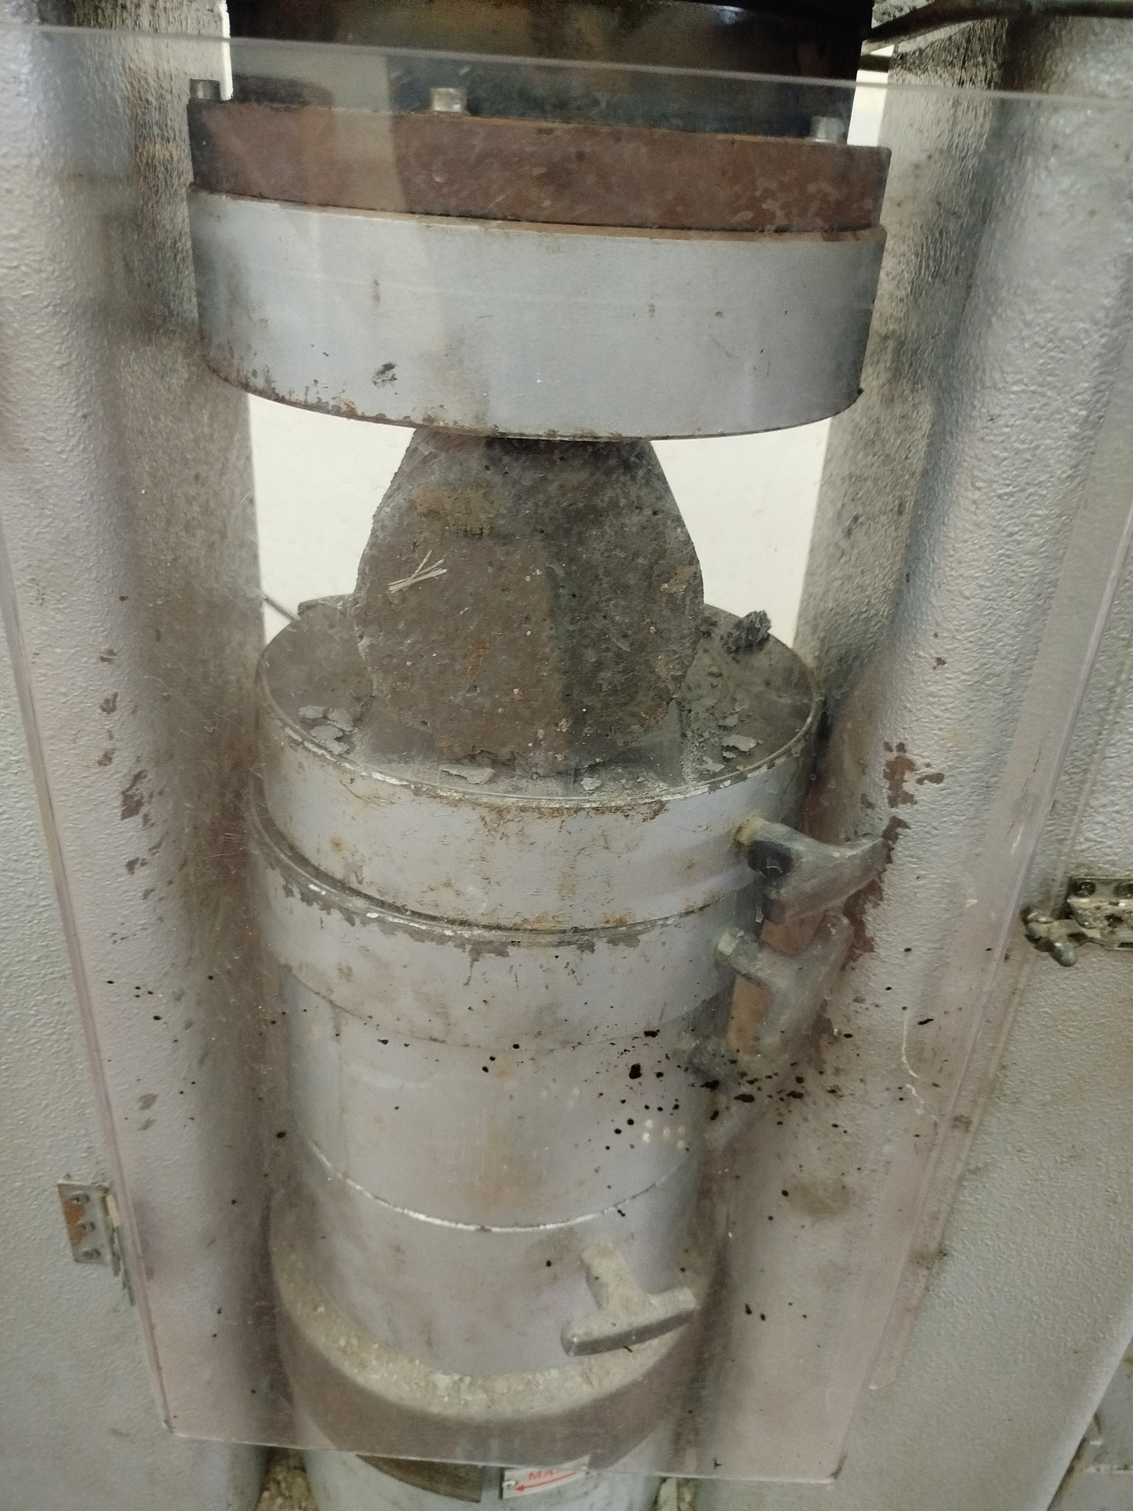

Appendix 8 Sample on the Machine before testing

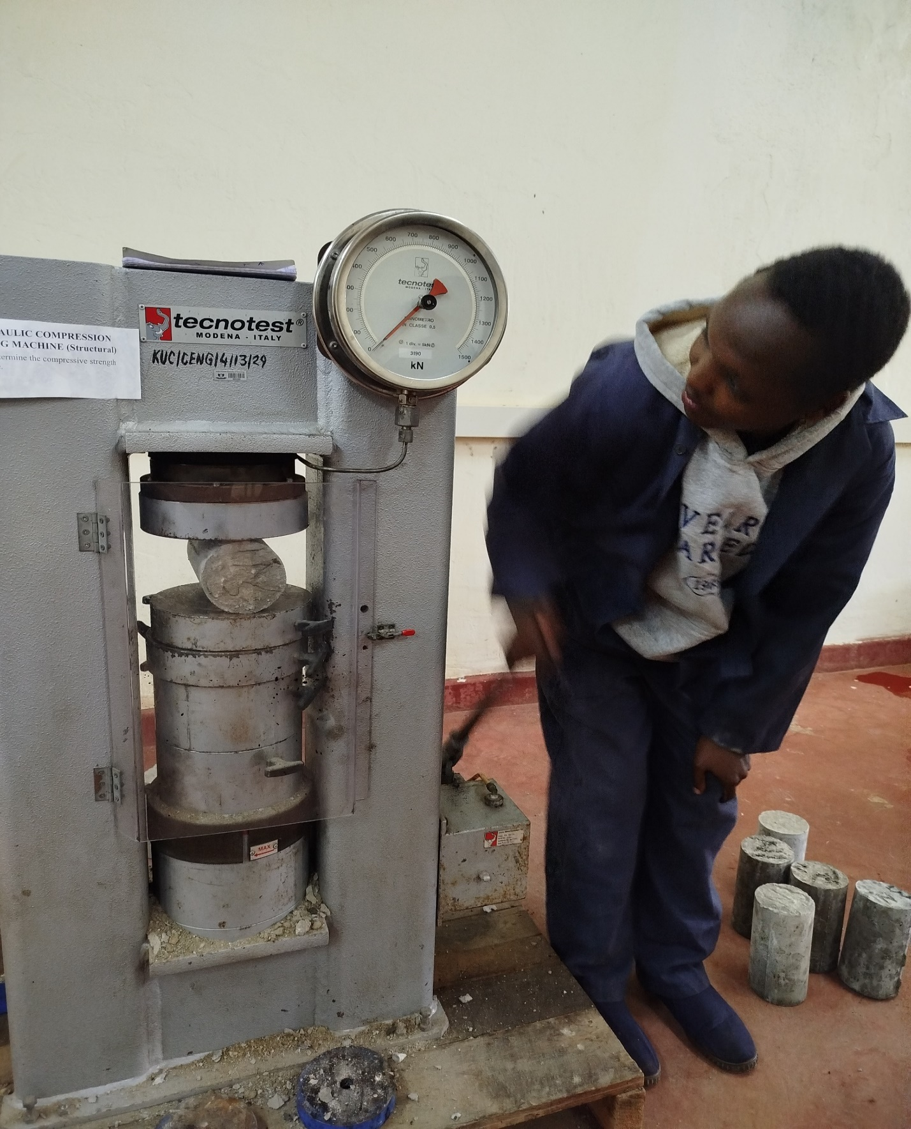

Appendix 9 Performing Test on Sample



Appendix 10 Samples before testing is done after they have dried up

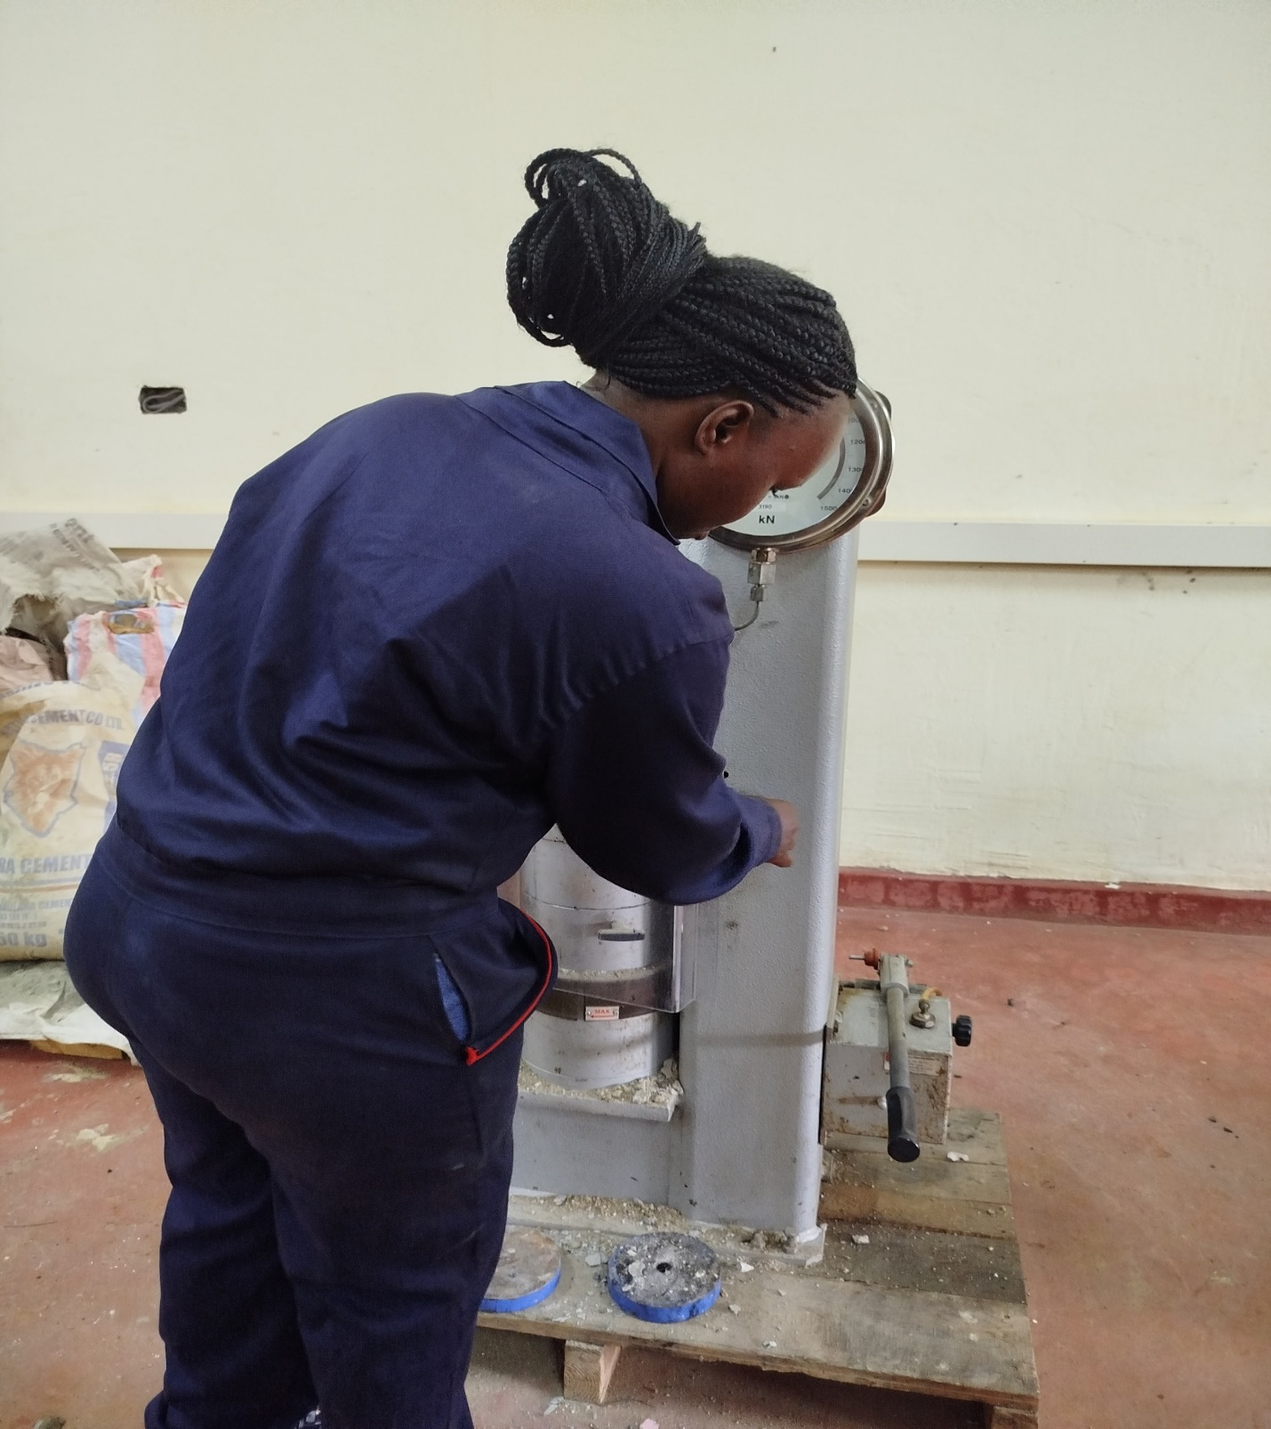

Appendix 11 Preparing the machine for testing



Appendix 12 Scale Before testing Begins

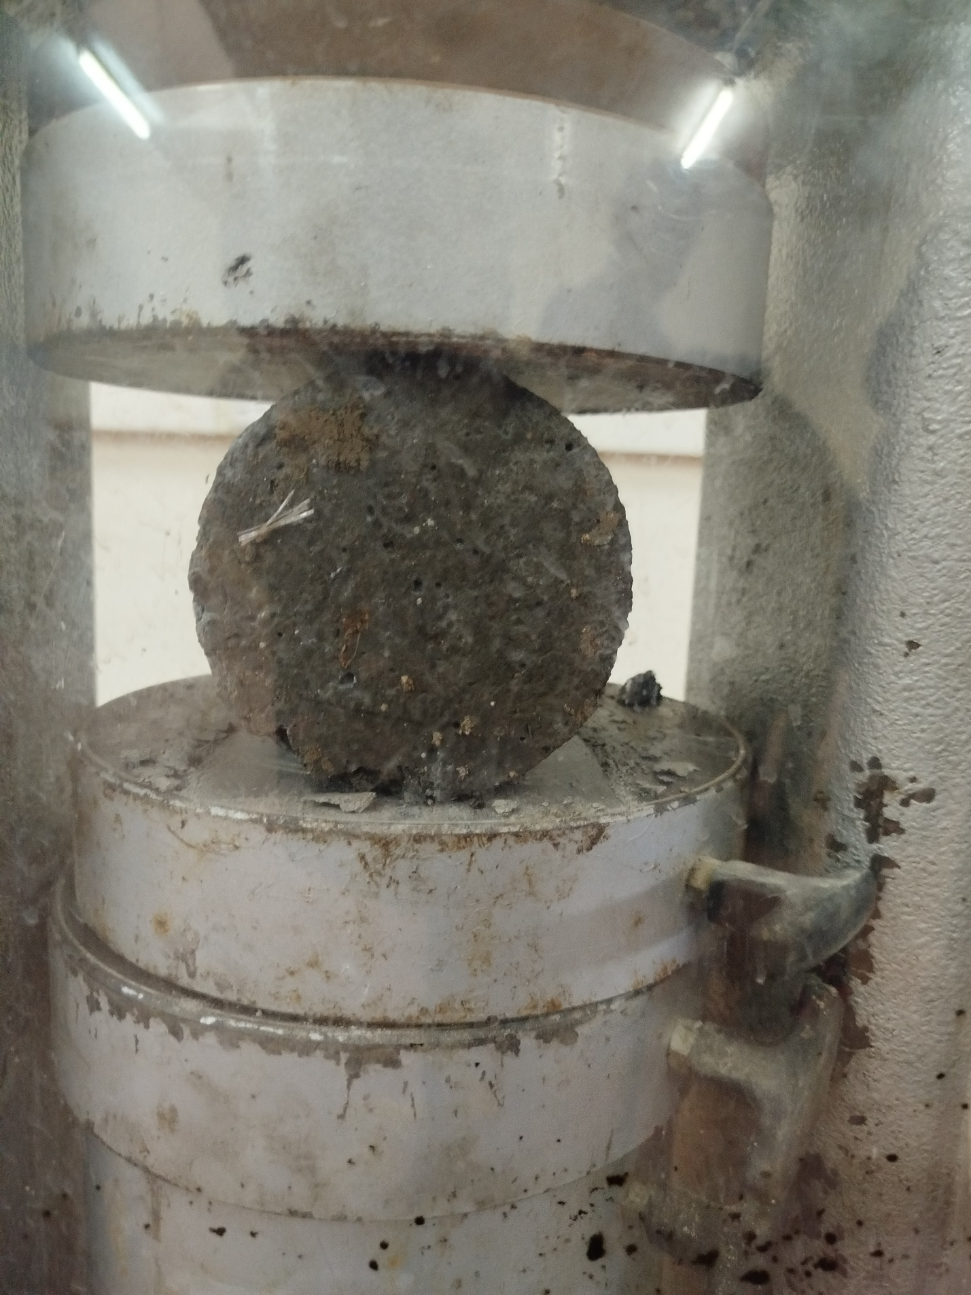

Appendix 13 Before Test Begins

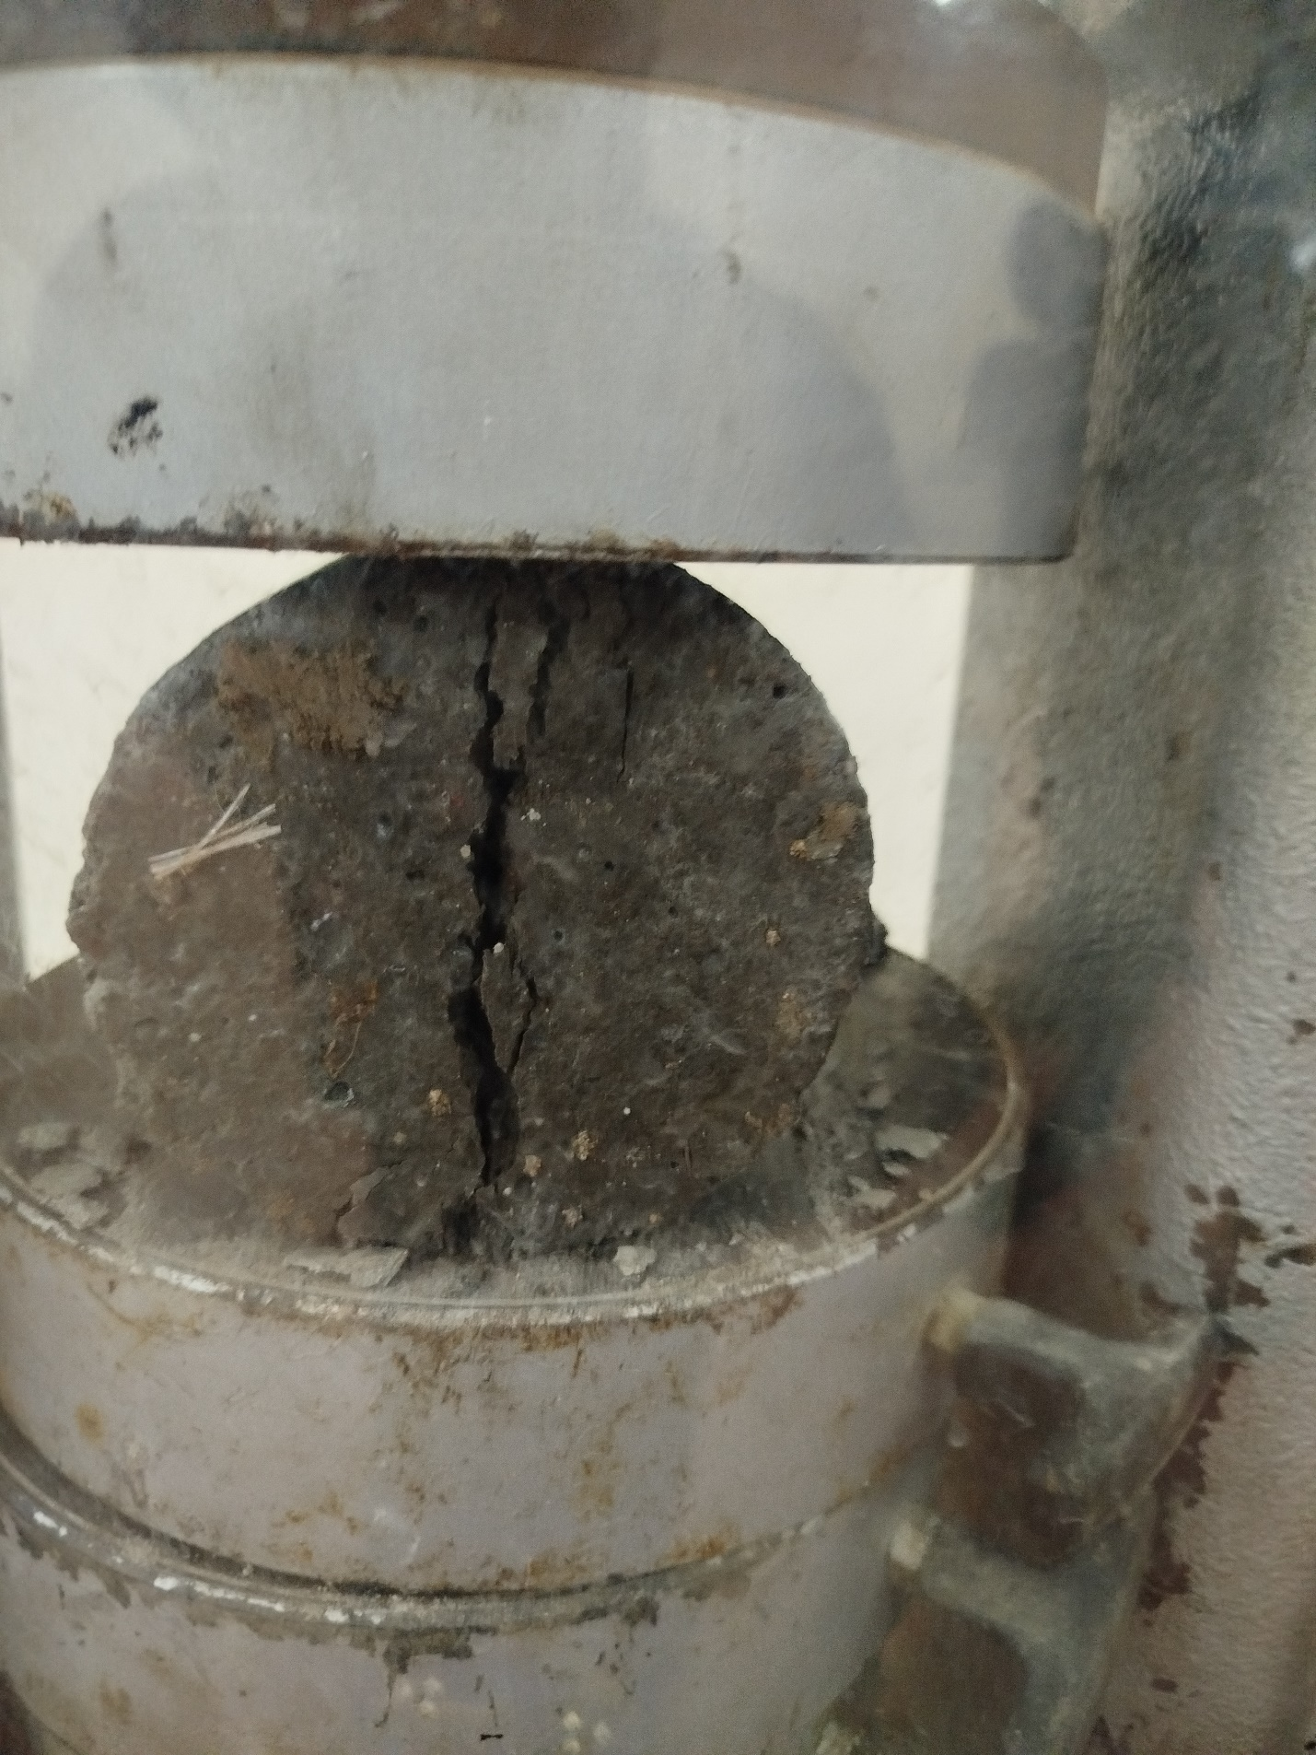

Appendix 14 After Test is completed

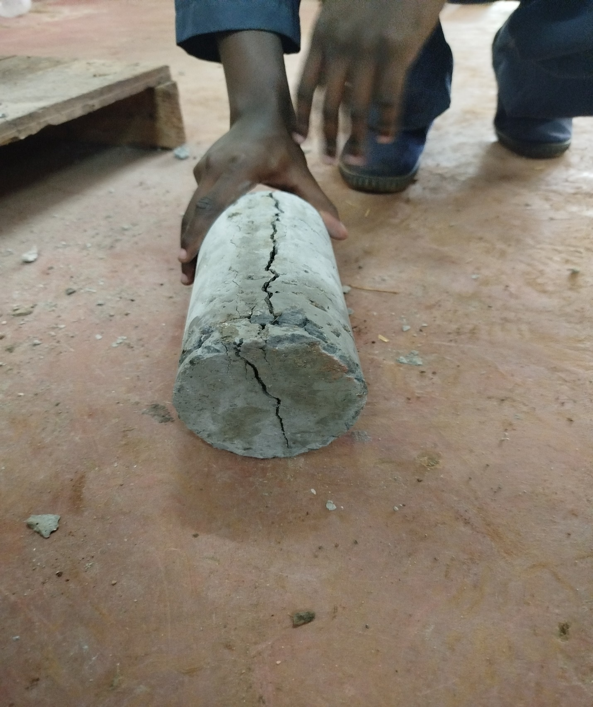

Appendix 15 The sample After testing Tensile strength